Title of the project: Fast Spectrum Neutron Source for Materials Irradiations

Technical work scope identifier: NEAMS-1

Technical Narrative:

Fast neutron Source Description

We propose a low-cost intense source of fast fission-spectrum neutrons for irradiation of materials of interest to the advanced fuel cycle. The source is based on the photo production of neutrons with a 40 MeV electron beam with a power of up to 10 kW. This accelerator energy and power level is within the capabilities of the accelerator now being commissioned at our university’s laboratory. The source is intended to irradiate small mm-scale samples with a fission-spectrum flux of 10¹⁴ n/cm²*sec. Fluxes greater than 10¹³ n/cm²*sec can be achieved for larger, cm-scale specimens. The source would be on a dedicated accelerator beam line and serve as a user facility for many university and national laboratory researchers as well as private sector users in need of fast neutrons.

A standard parameter measuring the radiation damage from ions and neutrons in materials is the displacement per atom (DPA). It is an integral characteristic that depends on the material response (displaced atoms) and the radiation (type, fluence and spectrum) to which the material was exposed. DPA is not representative of the initially created lattice defects but a measure of the number of atoms permanently displaced to a stable interstitial positions. Its magnitude is used to correlate damage on materials irradiated under different radiation environments. In a typical power reactor core of the order of 10⁻⁶ DPA/s are generated.
Relatively little data exist for samples in fast neutron spectra, and almost none at high temperatures. In general, the core materials in Generation IV reactors are expected to experience temperatures 500ºC-1000ºC and DPA in the range 30-100. Some aspects of the behavior of such reactor cores can be simulated by neutron bombardment of representative samples. The fast neutron fluxes available from the proposed source along with the convenience of use will make possible such studies and be a potential useful first step toward a larger such facility that could meet the national need for a fast neutron irradiation facility.

The device would have the following important characteristics:

- The neutrons have a nuclear “evaporation” energy spectrum very similar to a fission spectrum.
- The accelerator technology is simple, reliable, and inexpensive to build and operate as compared to fast reactors or accelerator spallation sources.
- The neutron producing target technology has been proven by a number of groups including previous experiments at our laboratory.
- Ready access to the facility for national labs and DOE-NE funded researchers.

The only accelerator-driven sources that produce evaporation, unmoderated, fission-like spectrum neutrons are those provided by GeV proton or deuteron beams or electron beams in the 10’s MeV range. In both cases high Z targets with adequate thermal cooling are used as converters. Electron driven sources have a clear advantage in facility cost for fluxes up to ~ 10¹⁵ n/s*cm²[1].
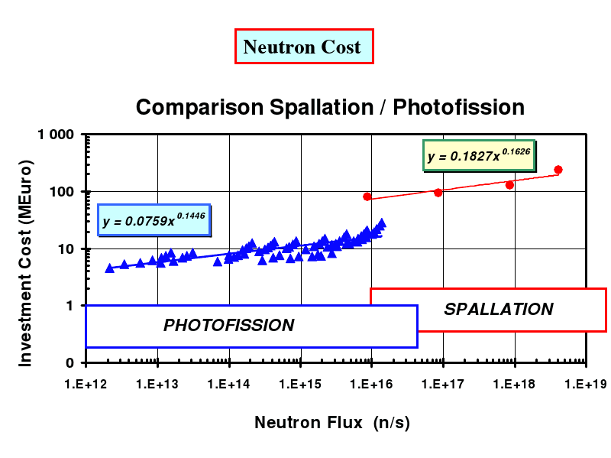
Figure 1. Comparison of the investment costs for electron-(photofission) and proton-(spallation) driven sources. Adopted from Henri Safa’s talk at the EURISOL Target Working Group Meeting, Saclay, May 21, 2001

Figure 1 shows a comparison of electron-driven sources (photofission) and proton-driven-sources (spallation) where one can see significantly higher investment costs for spallation sources.

As shown in Figure 2, the photo-produced neutron yield depends on the target material. For electron energies above ~15 MeV, high Z materials have the greatest yield per incident electron. Yield is directly proportional to beam current and it increases with energy. If the target material is fissionable, yields are ~2x higher due to the contribution of photofission neutrons. It is possible to take advantage of neutron multiplication if a fissile material assembly is present around the target structure. Such multipliers have exhibited neutron yield gains of more than 10. However, fissionable target materials and fissile material multiplying configurations carry the burden of higher levels of regulation and residual activity than those posed by non-fissionable converter materials. Above ~30 MeV the energy dependence of the yield begins to flatten out and one needs to consider the relative cost of a higher energy accelerator versus increasing the beam current to achieve a given neutron output. At electron energies above ~ 40 MeV the cost effectiveness of neutron production changes little.

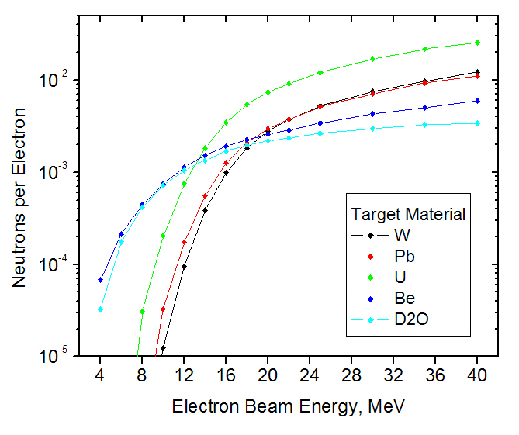
Figure 2. Neutron flux through a thick target as a function of the electron beam energy for different target materials.
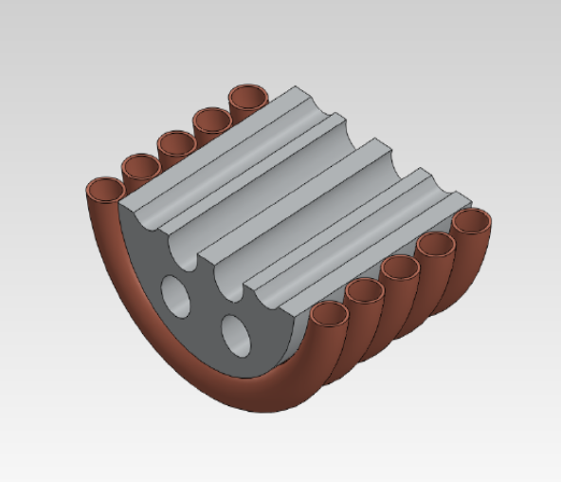
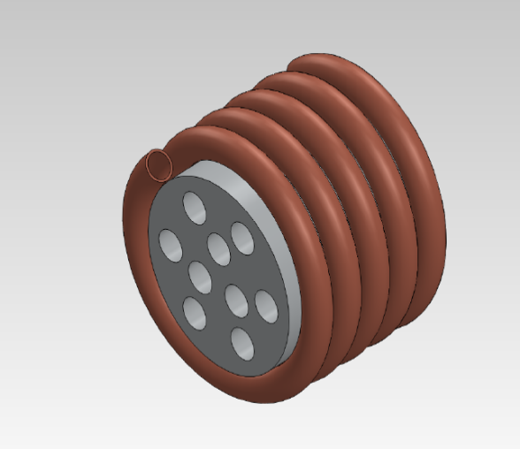

Figure 3. A schematic drawing of the fast neutron source. A high Z material cylinder will have cavities for sample. The water cooling coils are only a schematic representation of the cooling system.

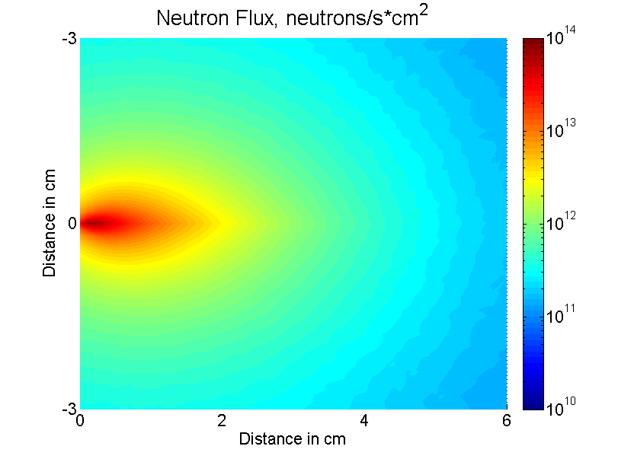
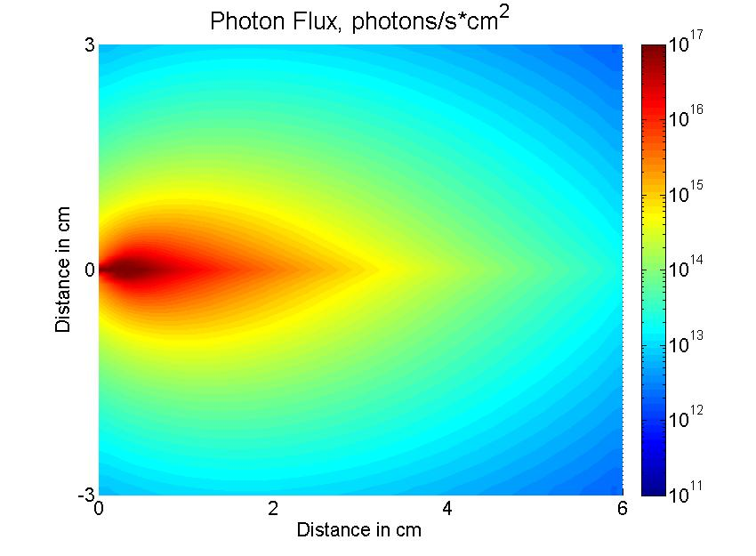

Figure 4. MCNPX simulations results for neutron (top) and photon (bottom) fluxes within the tungsten cylinder 6 cm long and 3 cm in radius. 40 MeV electrons are incident from the left. A 10 kW beam is assumed for the simulations. Using U-238 would increase the neutron flux by a factor of 2-3.
A cylindrical geometry is suggested by the cylindrical beam symmetry. We have completed MCNPX simulations which predict that, for electrons in the energy range of 40-50 MeV, the cylindrical target should have minimum dimensions of radius ~3cm and length~ 6cm. The surfaces of constant neutron flux are ellipsoids of rotation about the cylinder axis so that narrow sample cavities (tubes) should be arranged around and parallel to the axis, as in a revolver pistol (Figure 3). The MCNPX calculation was used to investigate the effects of bombarding a tungsten cylinder with 40 MeV electrons moving perpendicularly into the center of one of the circular ends of the cylinder.

Figure 4 shows the neutron and photon flux through the tungsten cylinder vertical cross-section. With a 40-50 MeV electron beam at 0.2 mA average current and with the choice of irradiation volumes of ~ 0.5cm³ one can achieve a number of irradiation regions where the flux is near 10¹⁴neutrons/cm²*s over the volume. Numerous lower flux positions can also be provided. The limit on the number of irradiation volumes arises from the effect the target void spaces will have on production. Preliminary results show that removing about 1% and 5% of the tungsten cylinder volume does not result in significant change in neutron flux and energy distribution as long as the cavity is not carved right through the axis of the electron beam. More detailed simulations, including thermal behavior and electron and photon flux, are required to design the final, optimum form of the converter target.
The neutron energy distribution was also simulated through different regions inside the cylinder. Figure 5 shows cross-section of the cylinder and the regions of interest. First, we looked at the neutron flux as a function of the depth of the cylinder. We considered the central “sub-cylinder”, 1 mm in diameter, and broke it into seven segments, first two – 0.5 cm long each; and the remaining five – 1 cm long each. The MCNPX code was used to calculate average neutron energy distributions through each segment (Figure 6). Then, we looked at the radial distribution. We considered the front 0.5 cm of the tungsten cylinder and calculated average neutron energy distributions through the rings (Figure 7).
High-Power Targetry Issues
Dealing with a high power electron beam (10-30 kW) requires special attention to a number of issues which are usually not a significant problem at lower power. Energy deposition was estimated to be close to 10MeV/cm³ per incident electron in the region very close to the electron beam entrance into the cylinder, which means there will be kilowatts of power deposited into a small volume. At the same time, on the edges of the cylinder the energy deposition drops by a factor of several thousand.
Of course, such a huge amount of localized heat will cause a tremendous temperature increase, and possible melting of the target and the samples unless the target is properly cooled. To avoid this, a cooling system needs to be designed and tested. For 10 kWatts a relatively simple water cooling system might be enough. In addition to water flow around the cylinder, it might be necessary to use some of the cavities for water circulation as well. More calculations will be done to estimate heat transfer and temperatures through the cylinder for different cooling systems to choose the optimum one. Experiments will be performed to confirm the simulations, first at low power, then at high power.
Another important issue in high radiation fields is radiolytic reactions, especially if water is present. It is well known that the irradiation of water ionizes it, and releases free radicals. These free radicals interact with other water molecules and cause them to form hydrogen and hydroxide ions. The two hydroxide ions then proceed to chemically combine to produce hydrogen peroxide [2]. The life-time of many of those radiolysis products (see Table 1), or radicals is short, on the order of milliseconds or less, except O₂ and H₂O₂. Both long lived and short lived radicals can lead to corrosion. The corrosion due to short lived species are of primary concern only when they are produced close to the materials that are exposed directly to the radiation [3,4]. Their effect is negligible if produced at some distance away from the material because of their short lifetimes. The long lived chemical species however can contribute substantially to the corrosion process. We will follow the high-power target scheme described by Capiello [5] and James [6]. Great resistance to radiolytic degradation was shown in their reports by using tantalum-clad tungsten.
H₂O + ɣ H₂O*H* + OH*

H₂O + ɣ H₂O⁺ + e⁻

H₂O + e⁻ H₂O⁻

H₂O⁺ + H₂O⁻ 2H₂O* 2H* + 2OH*

H* + H* H₂

OH* + OH*H₂O₂



Table 1. Schematic diagram of radiolysis of water.
1 2 3 4 5 6 7
8
9
11
10
9
11
10
11
1
8
9
10
8

Figure 5. Side view and front-view of the W cylinder, 3cm x 3 cm, and regions of interest, where neutron energy distributions were simulated (shown in Figure 6).

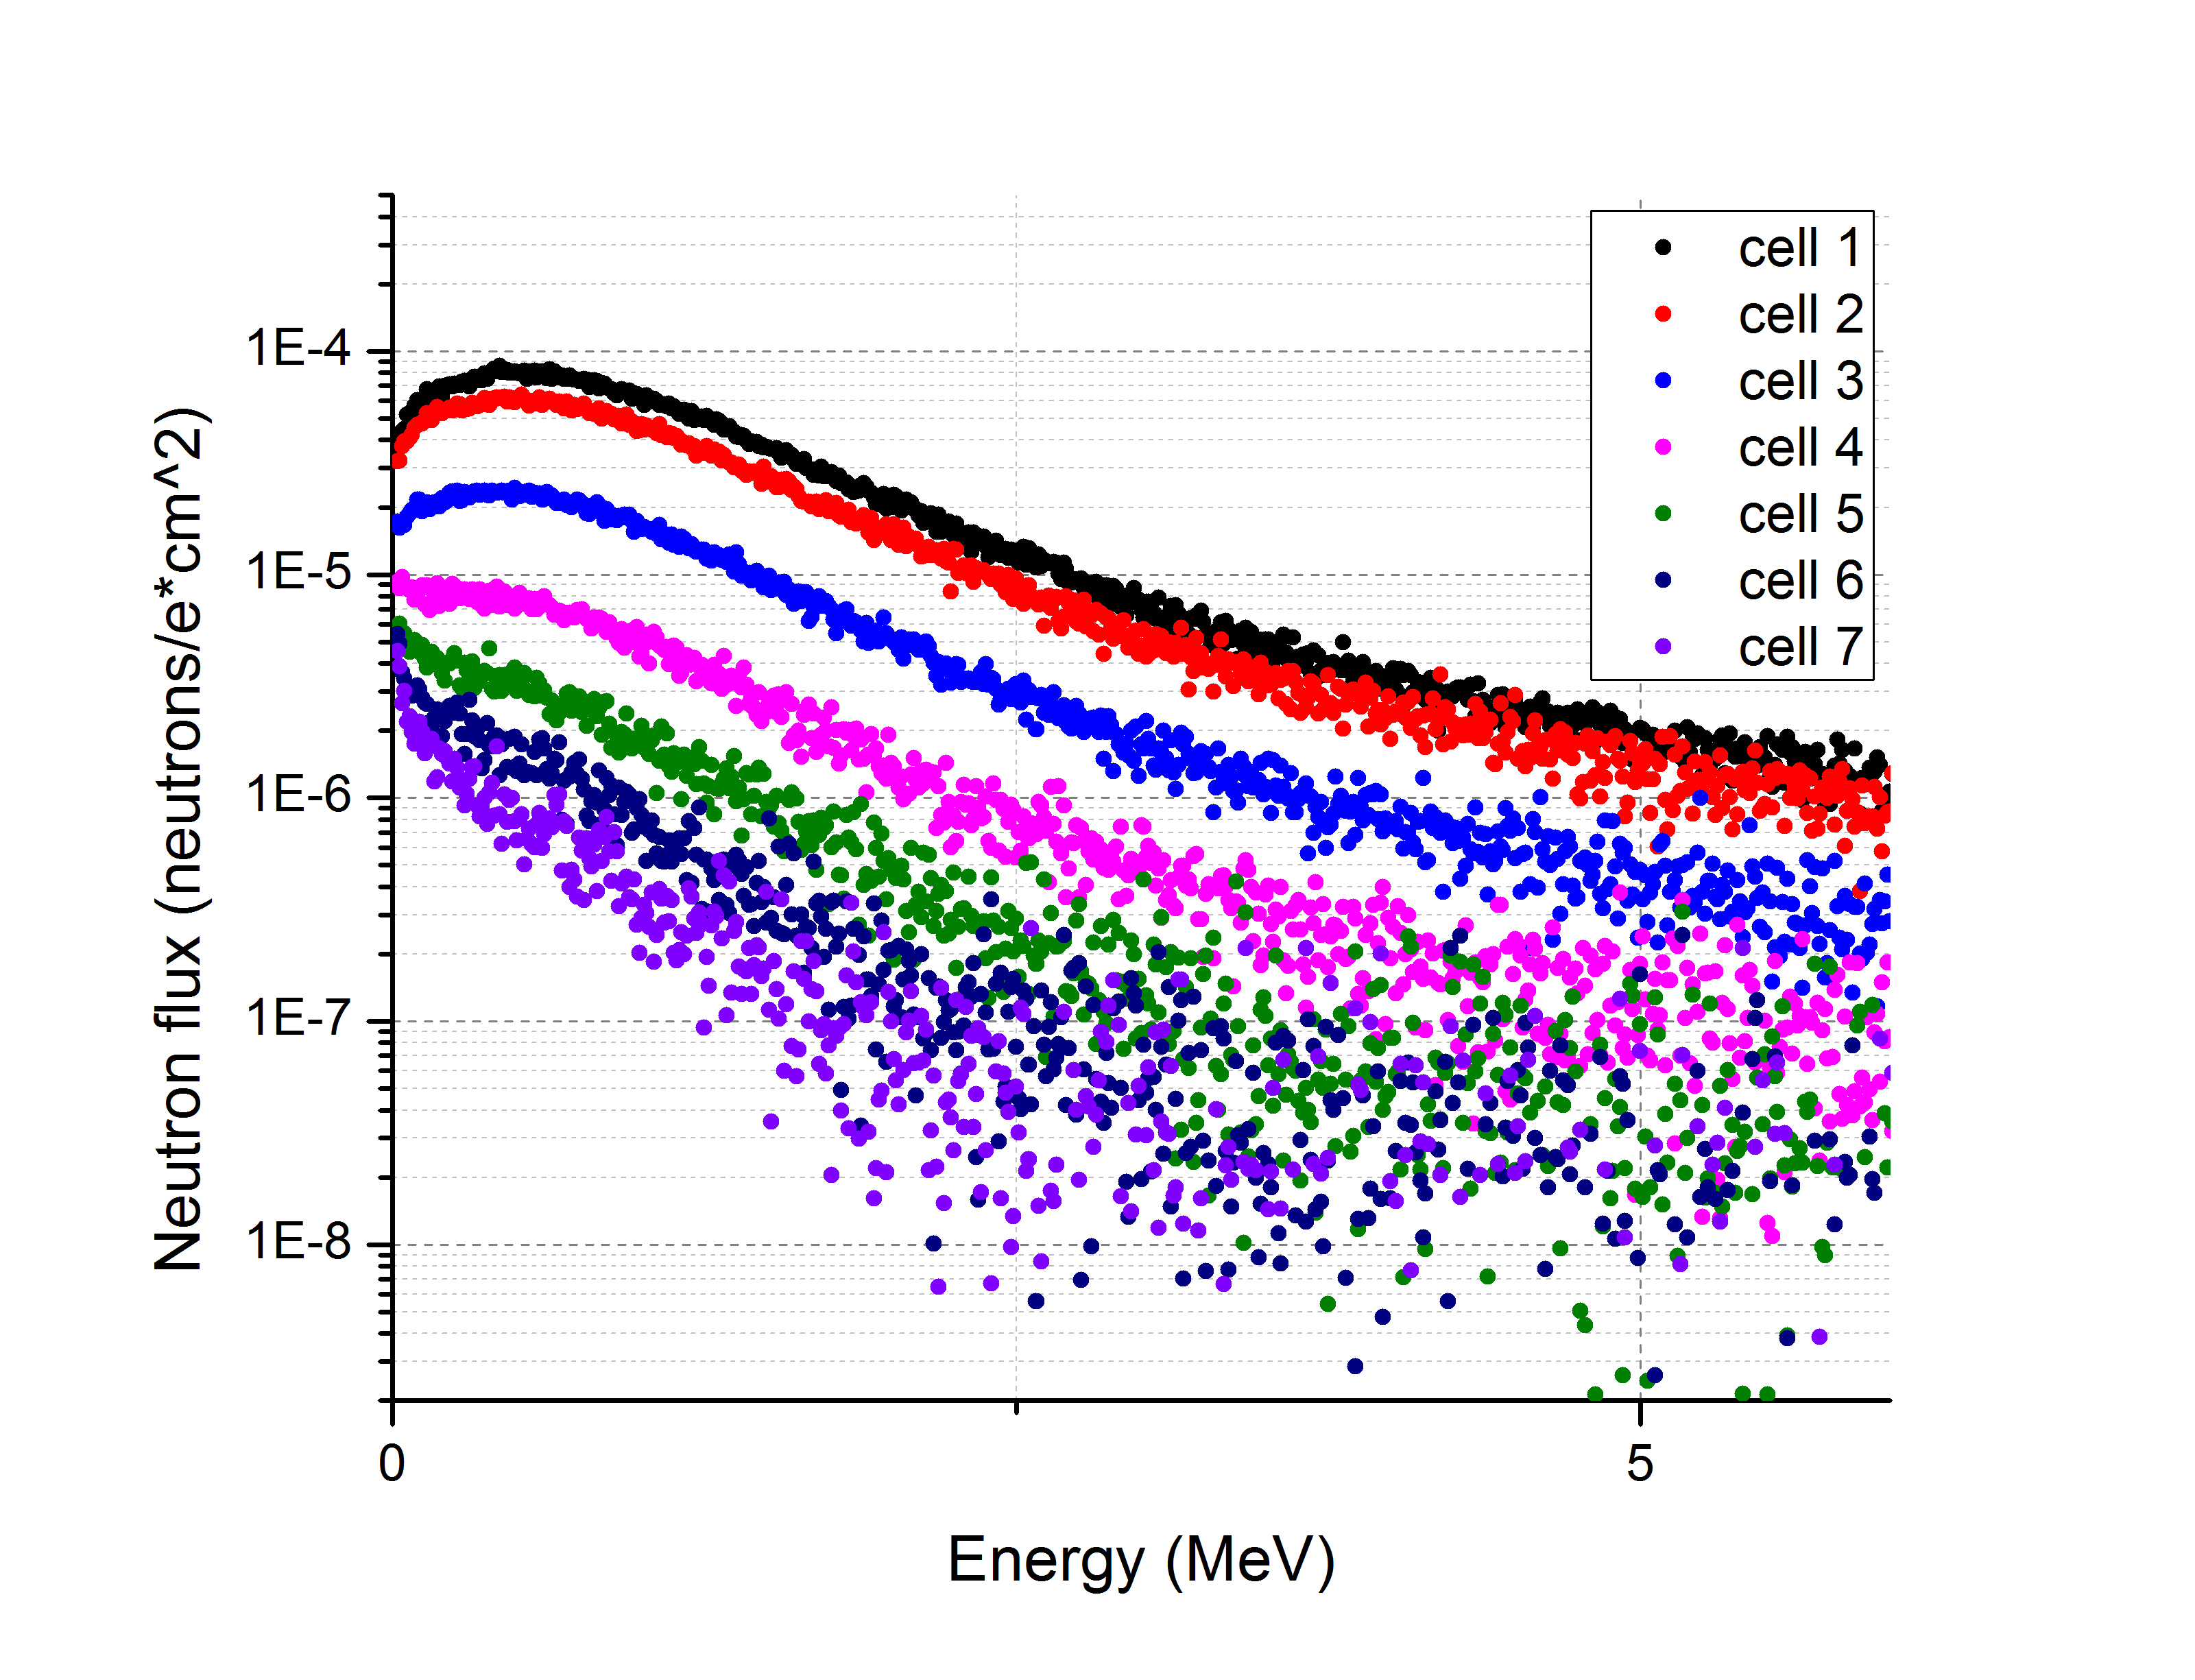
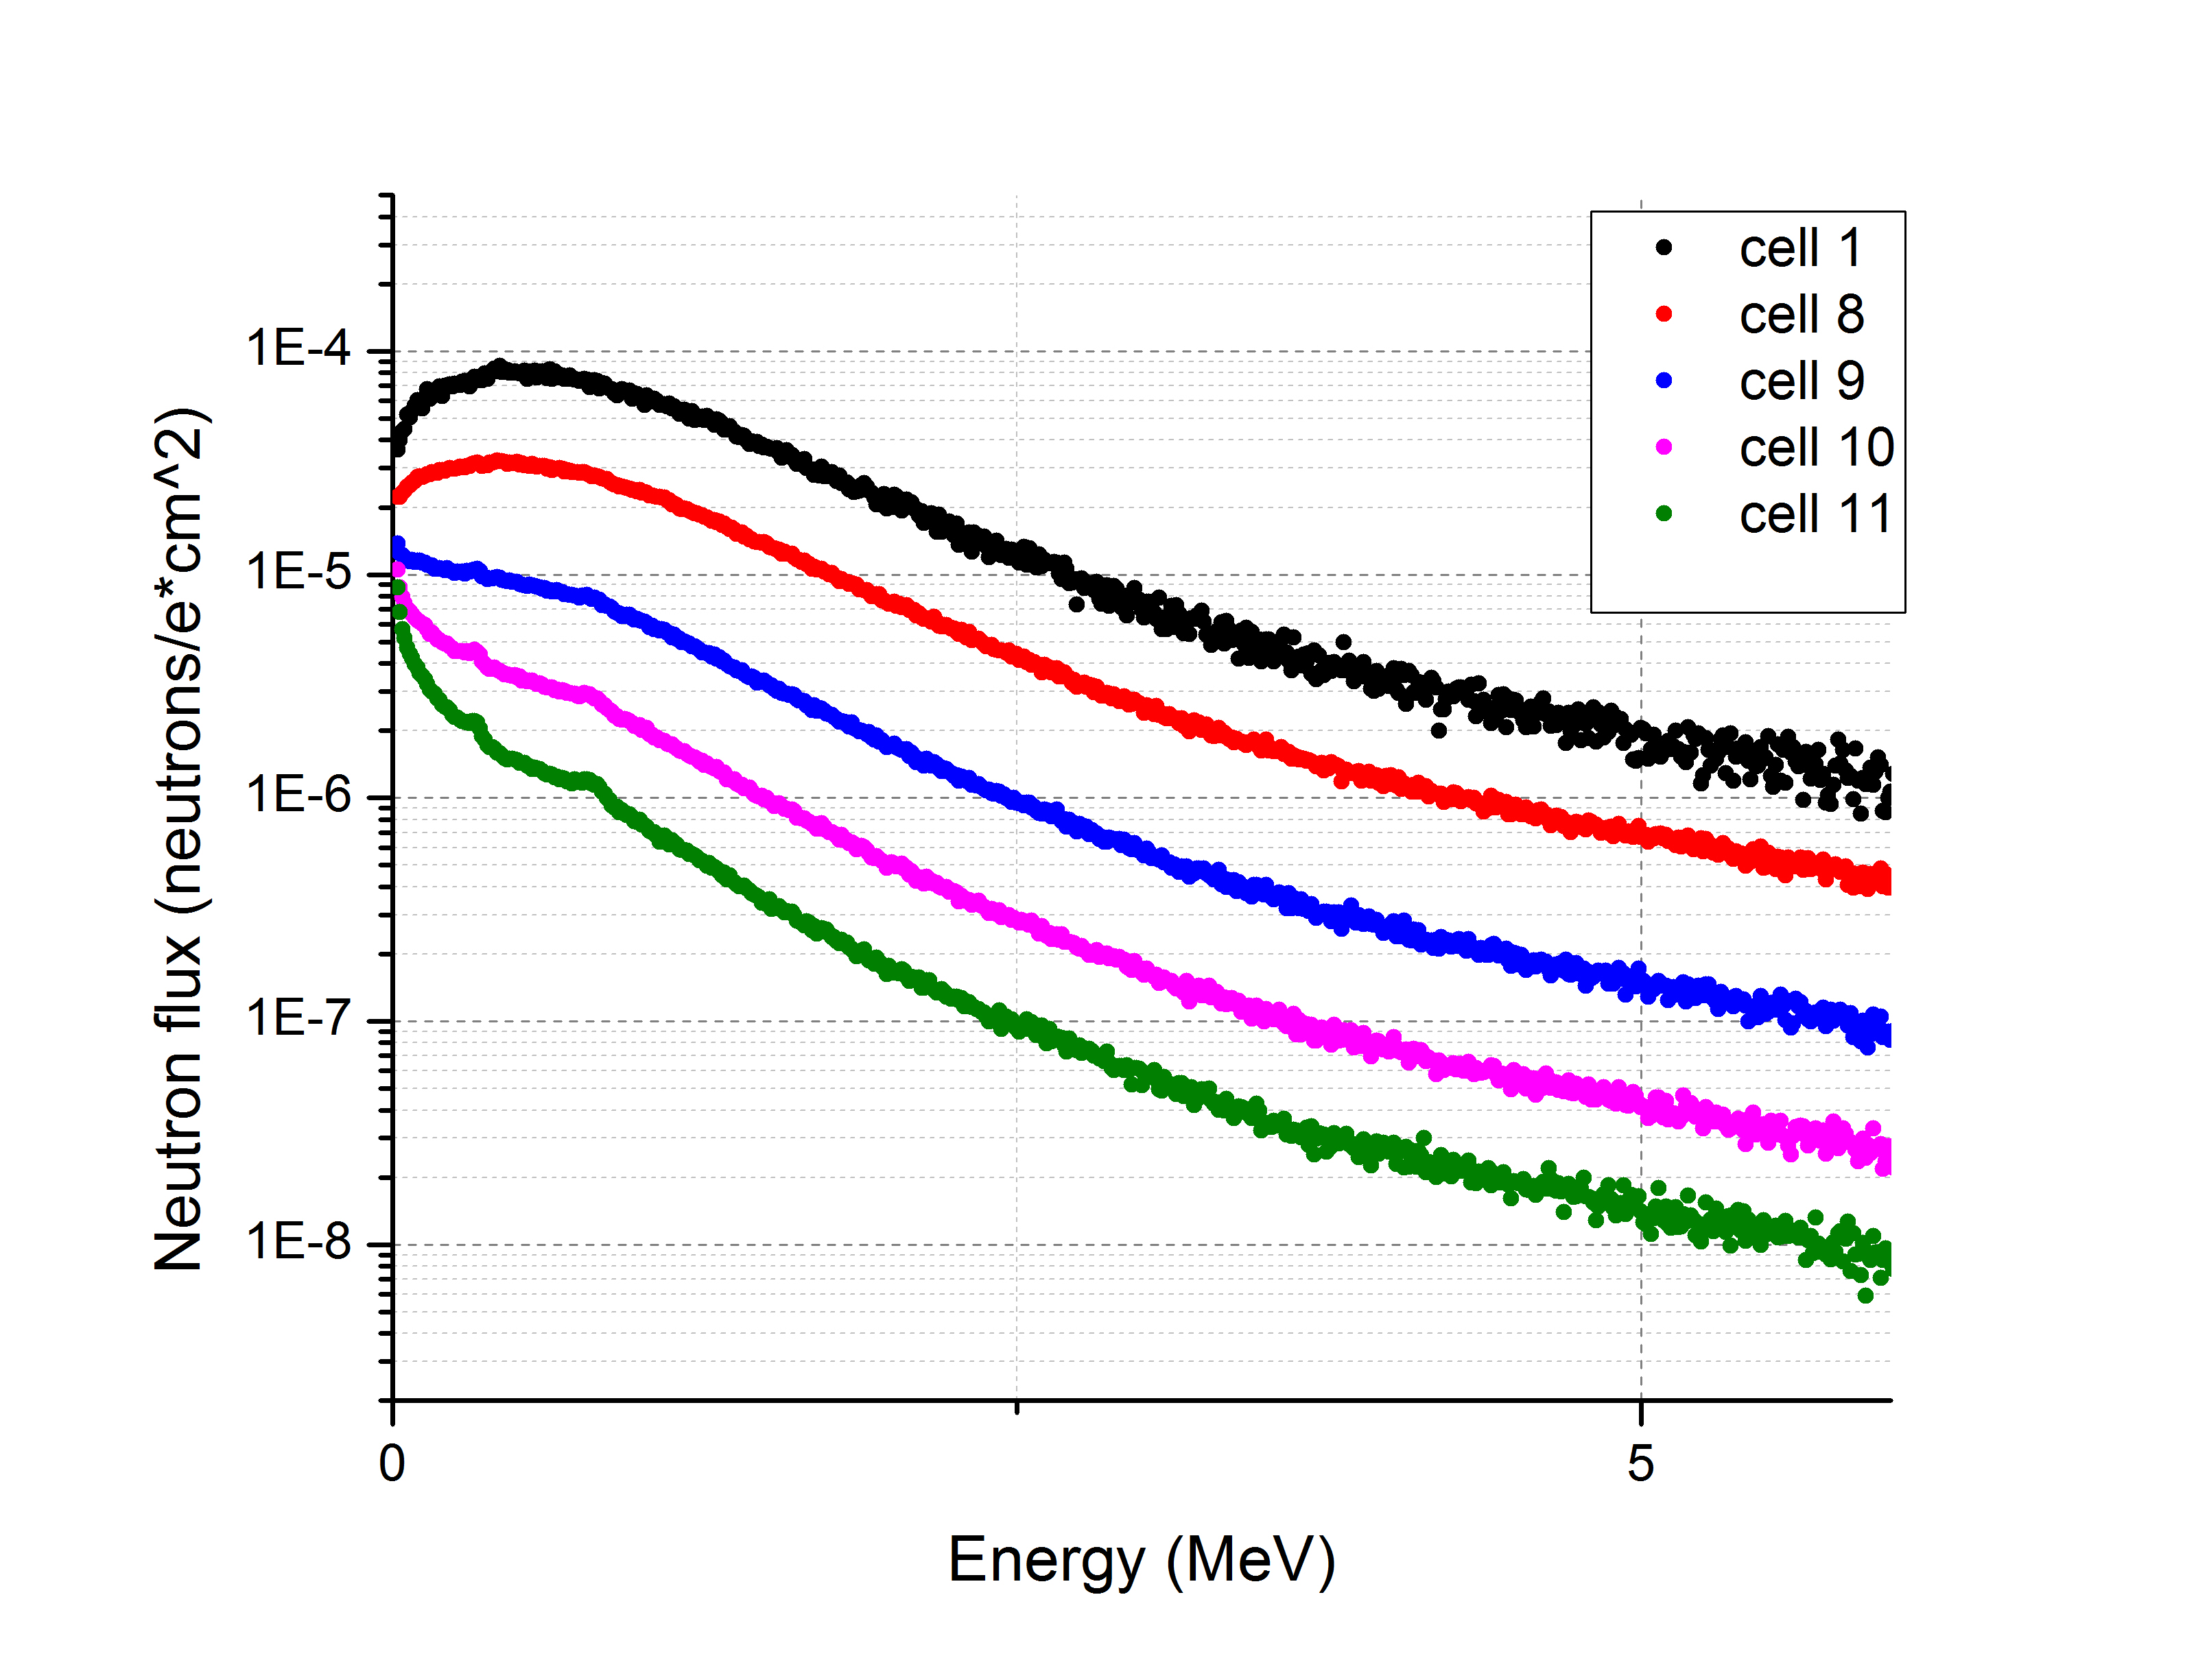
Figure 6. Neutron flux through regions 1-7 (left) and 1,8-11 (right) inside the tungsten cylinder. Simulated with MCNPX. Neutron flux is shown per electron. 5 keV energy bins were used for simulations.

Instrument location and use

The fast neutron irradiation source will be placed in front of the linear electron accelerator (LINAC). The LINAC is composed of two 2856 MHz sections, the first section is a standard standing wave, side coupled cavity, buncher/pre-accelerator injecting a 27 MeV beam (unloaded) into the second section which is a standard SLAC type traveling wave accelerator. Each section is provided with microwave power from its own 5 MW peak output klystron. The total unloaded output energy is expected to be ~ 50 MeV. The system’s klystron modulator, which drives both klystrons, is capable of supporting .35% duty factor microwave power from the klystrons, but the klystrons have a maximum duty of .7%, so considerable accelerator output power upgrades are possible. Assuming the maximum duty of .30% for the electron beam and a peak beam current of 100mA (which is about maximum for the first section) the average output beam power is ~12 kW.

The accelerator is located in a well shielded hall with standard interlocks, warning lights and radiation area monitors. The high photon and neutron fluxes associated with this device will require additional shielding above and beyond the standard concrete-shielded accelerator halls that we currently employ. To address this, we will construct a ~ 2000 kg removable concrete shielding wall with a HEPA ventilation system around the bremsstrahlung target and sample holder. This will simultaneously strongly attenuate gamma dose beyond the sample irradiation region, while producing much less neutrons than, for example, a comparable shield made of lead.
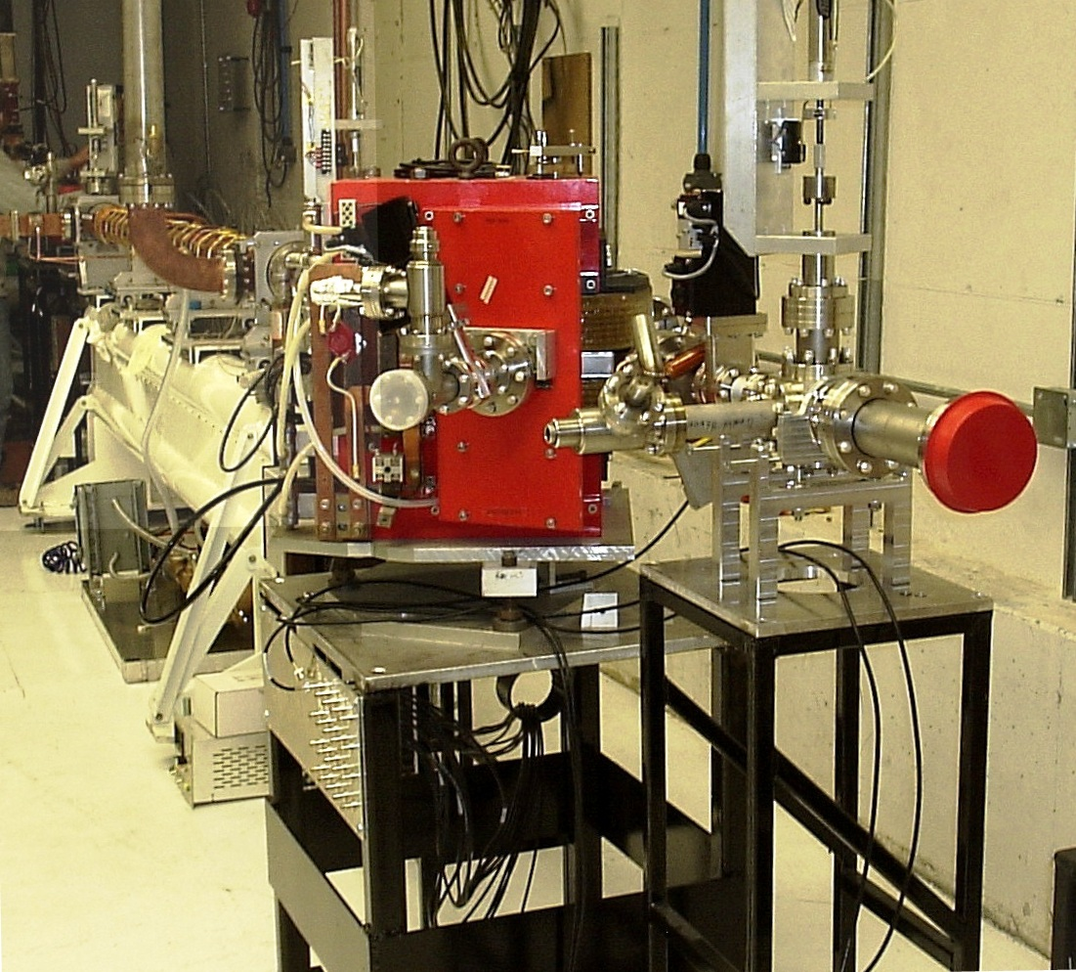
Post-irradiated samples will be pneumatically translated to a low-radiation environment and/or shielded location, depending upon their activity, where they can be subsequently analyzed. The above design and construction modifications are well within the experience and capabilities of staff engineers and scientists at our facility. A photograph of the existing accelerator and the location of the proposed testbed is shown in Figure 7.

Figure 7 10 kW+ 40 MeV LINAC. The proposed testbed will be placed right at the end of the beamline, surrounded by a thick concrete shielding wall.

Importance and relevance of the proposed work

Funding of this proposal will allow one to irradiate samples with a high neutron flux with a fission-like energy distribution, similar to cladding material in a reactor environment. Funding will provide a useful fast-neutron irradiation facility. It will also be possible to modify the setup with water for moderation. The cavities allow one to place samples in the desired neuron and photon flux field as well as control the temperature of the samples. In-situ observation and testing of in-situ devices might be made through the cavities as well. This will help validate models for different phenomena at various scales and can be extremely useful for investigation of devices and materials relevant to current and future generations of fuel, cladding and reactor vessels.

Logical path to completion

The proposed work scope will be accomplished within the planned 3-years of performance taking advantage of the project team experience in relevant nuclear R&D. Our team will complete the optimization and construction of targetry for neutron irradiation experiments. At the completion of this project we will have a fast neutron-irradiation source capable of 10¹⁴ neutrons/s*cm² for small, mm-sized samples.
Year 1: Monte-Carlo simulations for optimum converter material and geometry, mapping of neutron and photon flux through the converter. Experiments to confirm the simulations.
Year 2: Resolving the heating issues and temperature control experiments for both bremsstrahlung target and sample irradiation positions .
Year 3: Final experiments with control of both: temperature and neutron/photon fluxes. Possible converter modifications for in-situ observations. We will complete construction of high-power neutron irradiation target.
One of the co-PIs will lead the effort on simulations and measurements. Another will lead design and optimization efforts, while the PI will assume overall responsibility of keeping the project on-track and on-schedule.

Deliverables and outcomes:

- An intense fast fission-spectrum neutron irradiation facility will be developed.
- The nuclear physics and engineering aspects will be analyzed, explored for potential efficiency maximization approaches and documented. The potential to scale the facility up will be assessed and a report on the facility optimization will be delivered.
- Cost/benefit analysis will be performed using neutron flux, temperature and dosimetry data.
- Two graduate students will complete their degrees.

Target capabilities for the neutron and photon fluxes, doses and sample temperatures will be quantified. Project results will be documented in methodology specifications, reports, and journal articles. The R&D progress will be reported to DOE via quarterly and annual technical reports.
5
1

References:

[1] Henri Safa, EURISOL Target Working Group Meeting, Saclay, May 21, 2001
[2] A. Cecal et al. / Radiation Physics and Chemistry 62, 333–336, 2001
[3] R. Scott Lillard et al., The Corrosion of Materials in Spallation Neutron Sources
[4] R. Scott Lillard et al., Corrosion of Target and Structural Materials in Water Irradiated by an 800 MeV Proton Beam.
[5] Michael W. Cappiello, AFCI Materials Test Station, AFCI 17 February 2005, LA-UR-05-1118, Physics Calculations for the MTS
[6]Michael James, Erich Schneider, Holly Trellue, Günter Muhrer
MTS Pre-Conceptual Design Review, May, 2005

ANSI 2007 ASTM E693

