E166: Polarized Positrons & Polarimetry
K. Peter Schülerª
on behalf of the E166 Collaboration
ªDESY, D-22607 Hamburg, Germany

Abstract. A proof-of-principle experiment has been carried out in the Final Focus Test Beam (FFTB) at Stanford Linear Accelerator Center (SLAC) to demonstrate production of polarized positrons in a manner suitable for implementation at the International Linear Collider (ILC). A helical undulator of 2.54 mm period and 1-m length produced circularly polarized photons with a first harmonic endpoint energy of 8 MeV when traversed by a 46.6 GeV electron beam. The polarized photons were converted to polarized positrons in a 0.2-radiation-length tungsten target. The polarization of these positrons was measured using a Compton transmission polarimeter to have peak value in excess of 80%.
Keywords: ILC, polarized positron source, helical undulator, Compton transmission polarimeter
PACS: 29.27.Hj, 41.60.-m, 41.75.Fr,
Introduction

An important requirement for the ILC will be the development of an intense positron beam that matches the bunch charge and current of the electron beam. Conventional technology, as used at the Stanford Linear Collider (SLC), in which positrons are generated directly in showers from electrons of several GeV impinging a thick tungsten target, would be quite challenged to cope with target damage and activation issues associated with the considerably higher average beam currents that are required at the ILC. Furthermore, a conventional positron source cannot generate polarized positrons.
The important role of beam polarization in e+e- colliders was demonstrated with polarized electrons at the SLC. Even more powerful physics investigations can be carried out if both electrons and positrons are polarized [1]. If a positron beam polarization of about 60% can be realized, it will be possible to enhance or suppress, to a substantial degree, individual processes for different helicity configurations.
In the scheme proposed by Balakin and Mikhailichenko [2], a helical undulator is employed to generate photons of several MeV with circular polarization which are then converted in a relatively thin target to produce longitudinally polarized positrons.
Positrons generated in thin targets suffer less from multiple scattering and can therefore be collected with greater efficiency for subsequent acceleration. As the undulator is not expected to diminish the emittance of the drive beam in a significant way, one can directly use the primary high-energy electron beam of the ILC, either at full energy or at an intermediate energy of 150 GeV, to generate the undulator photons for positron production. However, in order to obtain the required high production rate of more than one positron per parent electron, a truly long undulator with a length of ~150 m is required at the ILC [3,4].
The purpose of the E166 experiment [5] was to explore the potential of this concept with a short scaled-down undulator structure in the final focus test beam (FFTB) at SLAC. Of primary importance is the degree of positron polarization that can be achieved. Particular emphasis was therefore placed on the polarimetry of the positrons.
In addition we also measured the polarization of the undulator photon beam.
The E166 Experiment

General Description

A schematic layout of the experiment is given in Fig. 1. The high-energy electron beam passes through the undulator and is then deflected with a chain of dump magnets (DM) into the beam dump (not shown). The photon beam generated in the undulator is analyzed by photon transmission polarimetry [5]. Positrons are generated by pair production in a 0.2 r.l. tungsten production target (T1) and deflected with a double-dipole spectrometer into the positron analyzer. A solenoid lens (SL) behind the production target helps to increase the useful positron flux. A second tungsten target (0.5 r.l.) in front of the positron analyzer reconverts positrons to photons (T2). The positron polarization is inferred from the polarization of the reconverted photons which is also measured by transmission polarimetry. A1 and A2 are identical aerogel flux counters with ~ 5 MeV threshold and associated silicon detectors S1 and S2. GCAL represents a silicon/tungsten photon calorimeter, P1 is a segmented positron flux detector, CsI is a Cesium-Iodide calorimeter detector behind the positron analyzer. C1-C4 are photon collimators and J identifies movable jaws in the positron spectrometer.

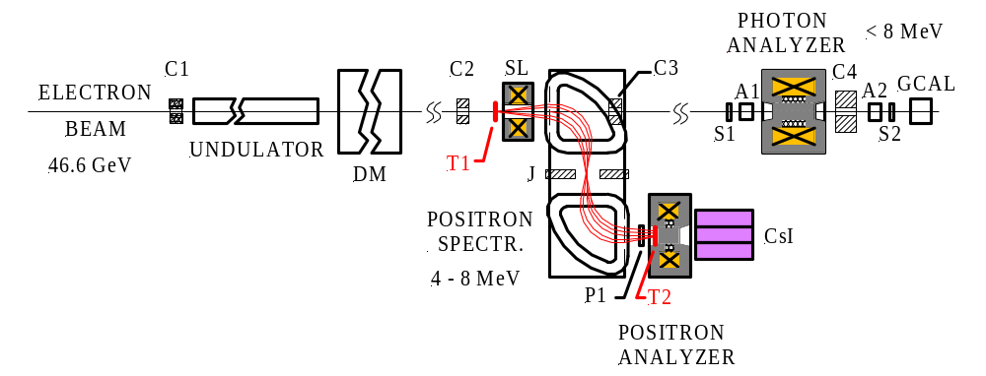

Figure 1. Schematic layout of the E166 experiment (not to scale).

Helical Undulator

The helical undulator employed in E166 has a length of 1 meter with a period of 2.54 mm and a clear aperture of only 0.9 mm. With an electron beam energy of 46.6 GeV, it generates circularly polarized photons of energy up to ~ 8 MeV, with energy spectrum and polarization (as shown in Fig. 2) appropriate for the ILC, only the intensity of the photons is lower in the demonstration experiment.
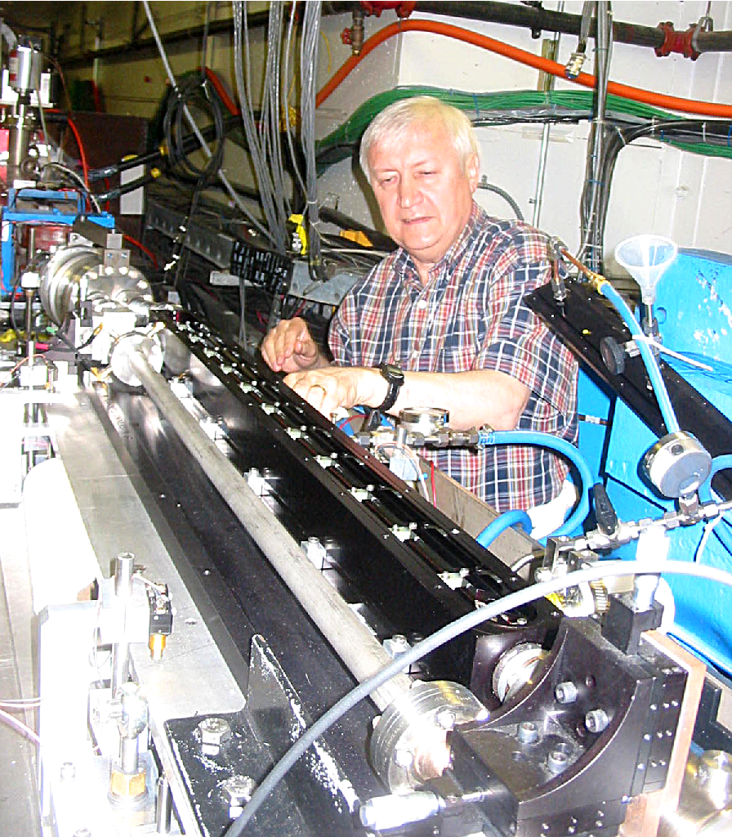

Figure 2. (a) Undulator photon spectrum dN/dE, integrated over angle, calculated for an electron beam energy E_{e} = 46.6 GeV, undulator period λ_{u} = 2.54 mm, and undulator strength parameter K = 0.17 which gives a peak energy ω₀^{max}
= 7.9 MeV for the first harmonic (dipole) radiation.
(b) Photon polarization, calculated for the same conditions as for the shown spectrum.
(c) The helical undulator during installation in the FFTB tunnel at SLAC.

A much longer undulator will be required for the ILC. In its baseline configuration [4] it has an active length of 147 meters with a period of 11.5 mm and a clear aperture of 5.8 mm. This undulator length will be sufficient for the ILC baseline program and result in a positron polarization of about 30% at full intensity. For a beam polarization of 60%, the length of the undulator will have to be upgraded. For the required field strength of 0.86 Tesla, the helical windings need to be superconducting, as it is no longer feasible to operate in pulsed mode as for E166. There will be forty-two 4 m long cryomodules. The basic undulator parameters for E166 and ILC are listed in Table 1.

TABLE . Comparison of undulator parameters for E166 and the current ILC baseline design.
 | E166 | ILC (RDR)
Electron beam energy (GeV) | 46.6 | 150
Field (T) | 0.71 | 0.86
Period (mm) | 2.54 | 11.5
K value | 0.17 | 0.92
Photon energy ω₀^{max} (MeV) | 7.9 | 10.0
Beam aperture (mm) | 0.89 | 5.85
Active length (m) | 1 | 147
Number of periods | 394 | 12800

Analyzer Magnets

Two analyzer magnets were employed for the measurement of the photon and positron beam polarization. Both are iron core solenoids with core dimensions of 50 mm² × 150 mm long for the photon analyzer, and 50 mm² × 75 mm long for the positron analyzer. The shape of the structure (Fig. 3) was modeled to obtain saturation magnetization over most of the cylindrical core volume except for the end regions.
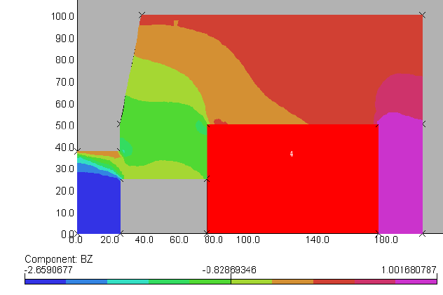
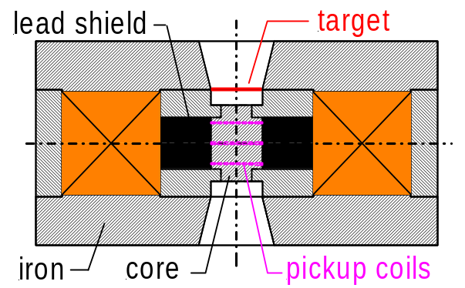

Figure 3. Analyzer magnet for positron polarimetry: (a) full cross section (left figure)
(b) 2d-field modeling (right figure) shown for one of four identical quadrants.

The polarization of electrons in the iron is given by P_{e}^{Fe} = M_{s} /(ρ_{e} μ_{B}) , where M_{s} = (M_{s}/M) M is the dominant spin part of the total magnetization M, ρ_{e} the electron density and μ_{B} the Bohr magneton. M_{s}/M = 0.958 ± 0.002 is known from Einstein-deHaas type experiments. We determined the saturation magnetization M from flux measurements with pickup coils in the central core region and used field modeling to account for the drop-off at the ends. For the positron analyzer, we obtain an average value of P_{e}^{Fe} = 0.0736 ± 0.0010 on the axis of the magnet, and P_{e}^{Fe} = 0.0695 ± 0.0015 for an effective cylindrical volume with 45mm diameter.

Results

The experiment collected data during June and September 2005. All of the results reported here are based on a 10 Hz beam pulse frequency. The signal in the positron flux detector was optimized for several spectrometer settings by scanning the current of the focusing solenoid lens. Figure 4 shows the beam pulse integrated photon signals in the CsI detector array from converted positrons. Electron beam halo showering in the undulator structure caused a relatively high background level (undulator off) in the CsI detector. Background was continuously recorded by delaying the undulator pulse timing for every other beam pulse.
The magnetization direction of the analyzer magnets was reversed every 3000 machine pulses (5 minutes at 10 Hz). Figure 5 shows background subtracted signals and asymmetries in the central CsI crystal for a typical run segment.

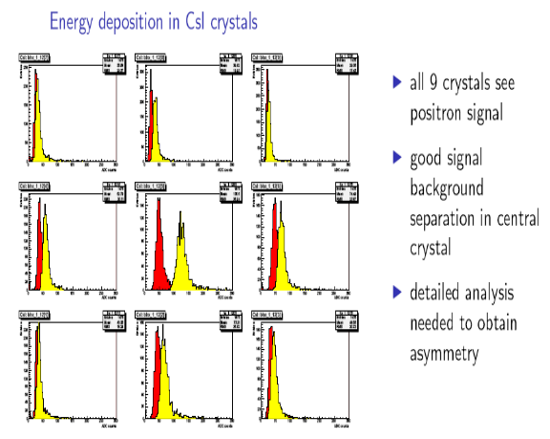

Figure 4 Calorimeter signal + background (light color) and background (dark color) distributions in the 3 x 3 CsI crystal array. The background was measured for every other beam pulse by delaying the undulator pulse by several microseconds.

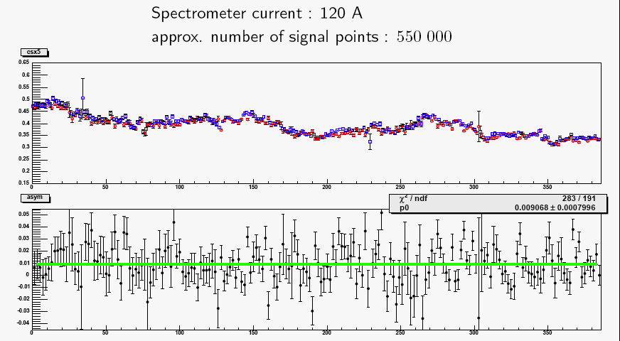

Figure 5 Background subtracted central CsI signals and asymmetries for a typical run segment.

Data were taken for six different energy settings of the spectrometer. Table 2 shows the measured asymmetry δ = (E₋ − E₊)/(E₋ + E₊) of background subtracted calorimeter signals (normalized to positron flux) for the central CsI crystal which has the most significant contribution.
The polarization P_{e} of the positrons (electrons) follows then from the relation δ = A_{e} P_{e}^{Fe} P_{e}, where A_{e} is the analyzing power, which is obtained from simulations, and P_{e}^{Fe} is the electron polarization of the iron material, discussed earlier. In addition to the positron measurements, which were of primary interest, we have also taken a single electron measurement with reversed spectrometer current of 160 A, corresponding to a total energy of 6.72 MeV. The curves shown in Fig. 6 are predictions from simulations which account for all relevant physical processes at these energies [6]. The apparent shift of 1 MeV between the curves originates from the kinematic difference between pair-produced positrons and Compton produced electrons. We have also measured the undulator photon asymmetry and found it in good agreement with the expected value.

TABLE 2. Asymmetry δ (in %) observed in the central crystal of the positron transmission polarimeter, and the corresponding analyzing power A_{e} and the longitudinal polarizations P_{e} (in %) as a function of total energy E_{e} in MeV.

E_{e} (MeV) | δ ± σ_{δ} (stat) | A_{e} | P_{e}± σ_{P} (stat) ± σ_{P} (syst)
4.6 (e+) | 0.69 ± 0.17 | 0.150 | 66 ± 16 ± 8
5.4 (e+) | 0.96 ±  0.08 | 0.156 | 89 ±  8 ±  9
6.1 (e+) | 1.08 ± 0.06 | 0.162 | 96 ±  6 ± 10
6.7 (e+) | 0.92 ± 0.08 | 0.165 | 80 ±  7 ±  9
6.7 (e−) | 0.94 ± 0.05 | 0.153 | 88 ±  5 ± 15
7.4 (e+) | 0.89 ±  0.20 | 0.169 | 76 ±  17 ±  12

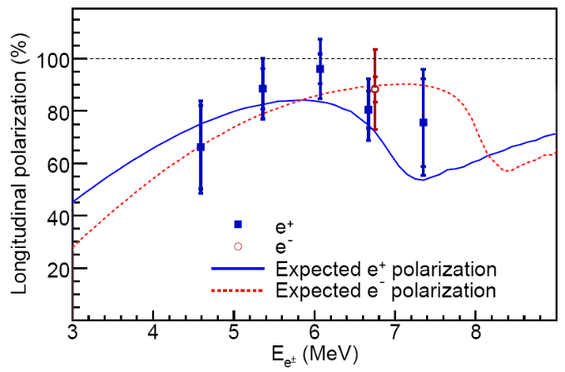
Figure 6. Measured positron beam polarization results (central CsI crystal only). An additional electron measurement at 6.72 MeV was obtained with reversed spectrometer field. The measurements are compared to predictions from simulations.

The results [7,8] of E166 validate our understanding of the photon-to-positron spin-transfer mechanism, which is no surprise, but nevertheless essential for any large-scale development of a polarized positron source for the ILC. The high positron polarization in excess of 80% observed in E166 can be considered as an important first milestone.

References
1. G. Moortgat-Pick et al., “The role of polarized positrons and electrons in revealing fundamental interactions at the Linear Collider”, Phys. Rep. 460, 131 (2008), hep-ph/0507011, July 2006.
2. V.E. Balakin and A.A. Mikhailichenko, “The Conversion System for Obtaining Highly Polarized Electrons and Positrons”, Budger Institute of Nuclear Physics, Preprint BINP 79-85 (1979).
3. K. Flöttmann, “Investigation toward the Development of Polarized and Unpolarized High Intensity Positron Sources for Linear Colliders”, DESY-93-161, Thesis, Universität Hamburg, 1993.
4. ILC Reference Design Report, Vol. 3 (Accelerator), ILC-REPORT-2007-001,
http://ilcdoc.linearcollider.org/record/6321/files/
5. SLAC Proposal E166, “Undulator-Based Production of Polarized Positrons”, June 2003.
6. R. Dollan, K. Laihem, and A. Schälicke, Nucl. Instrum. Methods Phys. Res. Sect. A 559, 185 (2006)
7. G. Alexander et al., Phys. Rev. Lett. 100, 210801 (2008).
8. G. Alexander et al., submitted to Nucl. Instrum. Methods Phys. Res. Sect. A.

