Laser Compton Scattered X-rays Production using Geant4 Monte Carlo Simulation Toolkit

Syed F. Naeem
Special Topics
Instructor: Dr. Tony Forest
Thesis committee members: Dr. Douglas P. Wells, Dr. Khalid Chouffani, Dr. Tony Forest
Idaho State University, Physics Department, Pocatello, ID 83209

Abstract - Laser Compton Scattered (LCS) X-rays are produced as a result of the interaction between accelerated electrons and a laser beam. The yield of LCS X-rays is dependent on the laser power, angle of collision between interacting particles, and the electron linear accelerator’s (linac) electron beam energy and current. One of our research goals focuses on exploiting Monte-Carlo simulations of LCS X-rays using Geant4 toolkit. The energy of LCS X-rays is tunable, that enable element-specific analysis for variety of nuclear sciences applications. A quasi-monochromatic 37.5 keV LCS peak was experimentally observed in based on electron beam tuned at 32.5 MeV that was brought in collision with the (Power)_{peak} = 4 GW Nd:YAG laser operating at 532 nm wavelength. Whereas, we produced approximately 37 keV monochromatic LCS X-rays following interaction between 37.5 MeV electrons and 532 nm laser using Geant4 Monte-Carlo simulation toolkit. The computer simulated and experimental results agree with each other and further Geant4’s open source capabilities will be exploited to use Geant4 as a benchmark tool to simulate the production of LCS X-rays.

- INTRODUCTION

  - LCS X-rays

Laser Compton Scattered (LCS) X-rays are produced as a result of the interaction between accelerated electrons and a laser beam. The relativistic electrons scatter low energy laser photons to a higher energy and hence also referred to as incoherent or Compton scattering of low energy laser photons. The direction of the back scattered LCS X-rays is governed by the direction of the electron beam, with divergence on the order of 1/γ, where γ is defined as the ratio of the incoming electron beam energy to the rest mass energy of an electron. [1]

  - Laser Photon and Electron Interaction Probability

The interaction probability or the differential scattering cross section that the photons, or laser photons in our case, will be scattered upon their collision with the relativistic electrons in Electron Rest Frame (ER) is simplified by Hartemann et al. [2] by representing the incident laser polarization vector as α´ and scattered photon polarization as η´ in ER frame as follows:
(1)
However, the differential scattering cross section was originally derived by Klein-Nishina [3, 4]:
(2)
Where dΩ´ = sinθ´dθ´ represents the solid angle of the photons being scattered in θ´ directions, r₀ is the classical electron radius, and R is the ratio between the energies of the scattered photons and the incident photons in ER frame. Hartemann et al. [2] and Stepanek [4] explained the production of LCS X-rays by first transforming the incident laser photons into ER frame and then the corresponding ER differential scattering cross section being transformed back into the laboratory frame. Figure 1 shows the schematic view of the electron and laser photon interaction process in Laboratory and ER frame.
E_{γ}

θ
E_{e}

E_{L}

E_{L}^{ER}

E_{γ}^{ER}

(E_{e}^{ER})´

m_{o}c²

φ
Lab frame

ER Frame

(E_{e})´

Figure 1. Schematic view of electron and laser photon interaction in laboratory and ER frame.

  - Lorentz Transformation

The ratio R between the energies of the scattered photons E_{γ}^{ER} and the incident laser photons E_{L}^{ER}, equation 2, in ER frame can be expressed as:
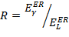 (3)
Lorentz transformation is used to boost the energy of incident laser photons from laboratory frame E_{L} into ER frame as follows [4]:
(4)

Where,
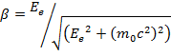 (5)
Kinetic energy of incoming electrons
= Electron rest mass energy, 0.511 MeV
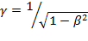 (6)
However, the Lorentz transformation, from laboratory frame into ER frame on z-axis, can also be expressed in matrix form that also includes the momentum of the photon both in laboratory frame and ER frame [5]:

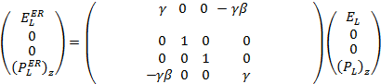 (7)

  - Energy of Compton backscattered X-rays

The yield of LCS X-rays is dependent on the laser power, angle of collision between interacting particles, and the electron linear accelerator’s (linac) electron beam energy and current. The energy gained by the backscattered X-ray photons is as follows [1]:
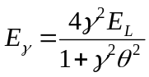 (8)
Where,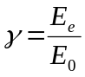, E_{e} is the electron beam’s energy and E₀ is the rest mass energy of an electron, E_{L} is the laser beam’s energy in electron volts (eV), and θ is the LCS X-rays emission angle in radians. The maximum Compton back-scattered photon energy can be estimated from equation 8 by assuming an approximate head-on collision between electrons and the laser:
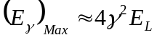 (9)

- METHODS AND MATERIALS (APPARATUS)

Geant4 is a Monte-Carlo simulation toolkit for the simulation of the passage of particles through matter and an ideal tool to investigate experimental parameters [6]. Compton process was used in Geant4’s PhyscisList class to simulate Compton backscattered X-rays (LCS) that were produced as a result of head-on collision between pencil-beam electrons and pencil-beam laser photons. Figure 2 shows the Geant4’s graphical view of the interaction between relativistic electrons and laser photons and table 1 shows the energy of incoming relativistic electrons and laser photons and the resulting LCS X-rays energy estimations using equation 8.

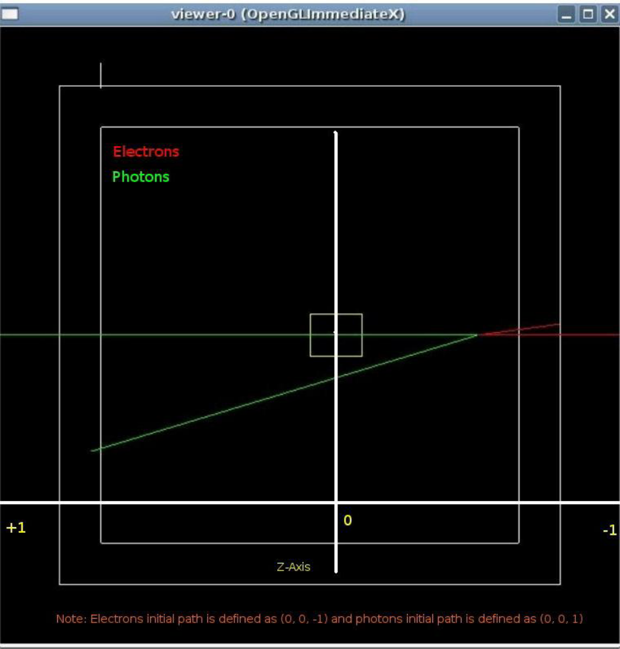
Figure 2. Geant4’s graphical view of the interaction between pencil-beam electrons (red) and pencil-beam laser (green).

E_{e} | E_{L} | θ  (Backscattered Compton X-rays emission angle) | γ = E_{e}/m₀c₂ | E_{γ}  (Eq. 8)
32.5 MeV | 532 nm = 2.3318 eV | 0 rad | 63.6007 | 37.72 keV
- | - | 1 mrad | - | 37.57 keV
- | - | 2 mrad | - | 37.12 keV
- | - | 3 mrad | - | 36.40 keV
- | - | 4 mrad | - | 35.43 keV
- | - | 5 mrad | - | 34.26 keV
- | - | 6 mrad | - | 32.93 keV
- | - | 7 mrad | - | 31.48 keV
- | - | 8 mrad | - | 29.97 keV
- | - | 9 mrad | - | 28.41 keV
- | - | 10 mrad | - | 26.86 keV
Table 1. Energy of incoming relativistic electrons and laser photons in laboratory frame and the resulting LCS X-ray energy using equation 8.

However, in order to simulate the interaction between relativistic electrons and laser photons and their corresponding backscattered Compton X-rays, the incident laser photons were first transformed into ER frame to interact with ER frame electrons and then the corresponding interaction result in ER frame, that is Compton back scattered X-rays, was transformed back into the laboratory frame.

As shown in table 1, the energy of incoming electrons to be simulated was 32.5 MeV and the laser photon wavelength was 532 nm. Following calculations, starting from equation 5, show the energy conversion of 532 nm (≈ 2.332 eV) laser photons from laboratory frame as follows:
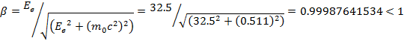

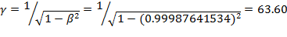

The ER frame photon energy can be calculated using equation 4 or 7:

Table 2 summarizes the laboratory and ER frame energy:

 | Laboratory Frame | ER frame
E_{L} (Laser photon energy) | 532 nm ≈ 2.332 eV | 296.612 eV
E_{e} (Electron energy) | 32.5 MeV | 0.511 MeV
Table 2. Laser photon and electron energy in laboratory and their corresponding energy in ER frame.

  - Lorentz Boost Implementation in Geant4

In order to “Lorentz Boost” the incoming laboratory frame photon into its ER frame, a custom global class "SharedLCSValues" was created to store incoming relativistic electron's energy to calculate β, γ, and LorentzBoost conversion factors:

LCSGlobals.hh

#ifndef LCSGLOBALS_HH
#define LCSGLOBALS_HH 1
#include "globals.hh"

class SharedLCSValues{
public:
SharedLCSValues(); //constructor
void setElectronEnergy(G4double);
G4double getElectronEnergy();
G4double getBetaCalculated();
G4double getComptonLorentzFactor();
~SharedLCSValues(); //destructor
private:
G4double IncomingElectronEnergy;
G4double BetaCalculated;
G4double GammaCalculated;
G4double ComptonLorentzFactor;
};

#endif

LCSGlobals.cc

#include "LCSGlobals.hh"

SharedLCSValues::SharedLCSValues(){IncomingElectronEnergy = BetaCalculated = GammaCalculated = ComptonLorentzFactor = 0.0;}

void SharedLCSValues::setElectronEnergy(G4double value){
IncomingElectronEnergy = value;

if (IncomingElectronEnergy <= 0)
{
G4Exception("LCSGlobals::LCSGlobals - Electron energy outside intrinsic process validity range");
}
}

G4double SharedLCSValues::getElectronEnergy(){
return IncomingElectronEnergy;
}

G4double SharedLCSValues::getBetaCalculated(){

BetaCalculated = IncomingElectronEnergy/(sqrt(IncomingElectronEnergy*IncomingElectronEnergy+0.511*0.511));
return BetaCalculated;
}

G4double SharedLCSValues::getComptonLorentzFactor(){

BetaCalculated = IncomingElectronEnergy/(sqrt(IncomingElectronEnergy*IncomingElectronEnergy+0.511*0.511));
GammaCalculated = 1/sqrt(1-BetaCalculated*BetaCalculated);

ComptonLorentzFactor = GammaCalculated*(1-BetaCalculated);

return ComptonLorentzFactor;
}

SharedLCSValues::~SharedLCSValues(){}

- RESULTS (OBSERVATIONS)

  - Simulation Parameters

LCS X-rays are produced as a result of interaction between relativistic electrons and pulsed laser, and experimentally both electrons and laser photons are synchronized with respect to each other. A macro file was used in the Geant4 simulation to specify incoming electron beam parameters such as electron beam energy with a peak energy of 32.5 MeV, beam’s energy spread within 1% of the peak energy, shape of the beam governed by the power law, direction of incoming electrons with respect to their target that is 532 nm laser, and number of events to simulate.

gps.mac
...
...
...

#/gps/direction 0. 0. -1 #Head-on collision
#/gps/direction 0. 5. -1. #11.09 degrees off-axis
#/gps/direction 0. -5. -1. #11.09 degrees off-axis
#/gps/direction 0. -0.75 -0.25 #45 degrees off-axis
#/gps/direction -0.25 -0.25 -0.5 #90 degrees off-axis

/gps/ene/type Pow
/gps/ene/alpha 10 #Default alpha = 0

/gps/ene/min 32.175 MeV #1% energy spread
/gps/ene/max 32.5 MeV
#/gps/ene/ezero 2.

/run/beamOn 1000000
exit

  - Lorentz Transformation

Lorentz transformation was used to boost the energy of incident laser photons from laboratory frame E_{L} into ER frame. The incident pencil beam laser photons of 532 nm wavelength (approximately 2.33 eV) and 32.5 MeV relativistic electrons were Lorentz boosted into approximately 295 eV and 0.511 MeV before their interaction with each other to produce backscattered Compton X-rays. Figure 3 shows the simulated energy versus yield plot of laser photons in ER frame.

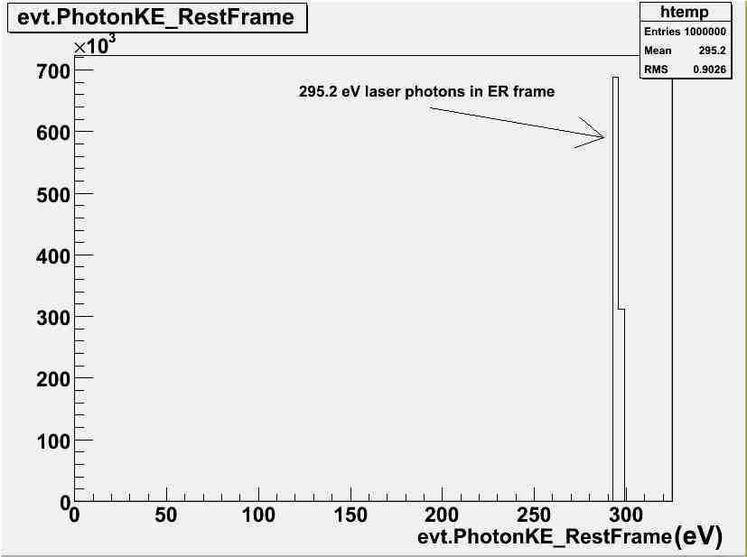
Figure 3. Laser photons of 295.2 eV mean energy in ER frame. The incident laser wavelength was 532 nm (2.33 eV) in laboratory frame.

  - LCS X-rays

Figure 4 shows the production of LCS X-rays as result of interaction between electrons and laser photons in ER frame and the resulting Compton back scattered photons were boosted back into laboratory frame. However, the simulation predicts LCS X-ray peak energy of 18.5 keV which approximately differs by a factor of two from the calculated value of 37.72 keV. For the purpose of comparison, another simulation was performed in BDSIM, which is a Geant4 extension toolkit for beam line simulations [7]. BDSIM also simulated LCS X-ray peak energy of 18.5 keV as shown in figure 5.

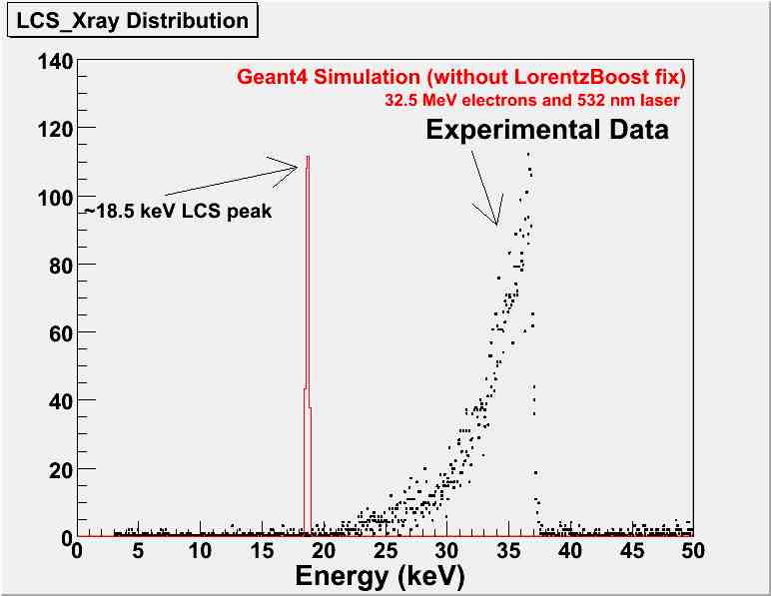
Figure 4. Geant4 simulated 18.5 keV LCS X-rays following interaction between 32.5 MeV electrons and 532 nm laser.

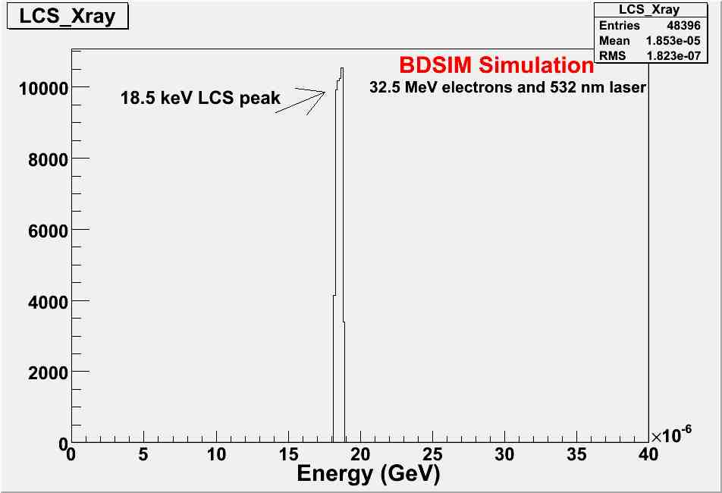
Figure 5. BDSIM simulated 18.5 keV LCS X-rays following interaction between 32.5 MeV electrons and 532 nm laser.
To correct Geant4’s “Lorentz Boost” function, a custom global class "SharedLCSValues" was created to store incoming relativistic electron's energy to calculate β, γ, and LorentzBoost conversion factors. Figure 6 shows the simulated LCS X-ray peak, following Lorentz Boost fix, and that corresponded with the calculated value of approximately 37 keV.

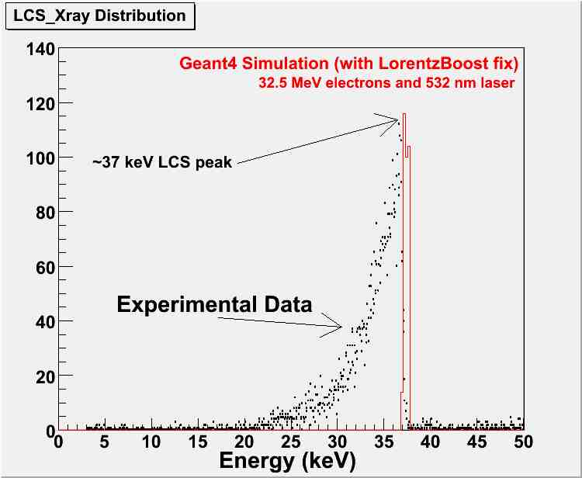
Figure 6. Geant4 simulated 37 keV LCS X-rays following interaction between 32.5 MeV electrons and 532 nm laser with Lorentz Boost fix.

- CONCLUSIONS

Laser Compton Scattered (LCS) X-rays are produced as a result of the interaction between accelerated electrons and a laser beam. LCS X-rays in Geant4 Monte Carlo simulation toolkit were produced by first transforming the incident laser photons and electrons from laboratory frame into ER frame and then the corresponding ER frame differential scattering cross section results being transformed back into the laboratory frame. Lorentz transformation function was used to boost the energy of incident laser photons of 532 nm (2.33 eV) from laboratory frame E_{L} into ER frame that is 295 eV to interact with electrons also boosted into ER frame. However, the simulation, both in Geant4 and BDSIM, predicts LCS X-ray peak energy of 18.5 keV which approximately differs by a factor of two from the calculated value of 37.72 keV. To correct Geant4’s “Lorentz Boost” function, a custom global class "SharedLCSValues" was created to store incoming relativistic electron's energy to calculate β, γ, and LorentzBoost conversion factors. The simulated LCS X-ray peak, following Lorentz Boost fix, agreed with the calculated value of approximately 37 keV.

REFERENCES
- Chouffani K., Wells D., Harmon F., Jones J., & Lancaster G., Laser-Compton scattering from a 20 MeV electron beam, Nuclear Instruments and Methods in Physics Research A, vol. 495, pp 95-106, 2002

- Hartmemann F. V. et al, Characterization of a bright, tunable, ultrafast Compton scattering X-ray source, Laser and Particle Beams, pp. 221 – 244, vol. 22, 2004

- Klein O., Nishina Z., Physik, pp.853, vol. 52, 1929

- Stepanek, J., Parametric Study of Laser Compton-backscattering from free relativistic electrons, NIM-A, pp. 174 – 182, vol. 412, 1998

- Forest relativity notes, http://wiki.iac.isu.edu/index.php/Forest_Relativity_Notes#Lorentz_Transformations, 2009

- http://www.geant4.org/geant4/, 2009

- http://www.pp.rhul.ac.uk/~malton/bdsim/bdsim.html, 2009

