Design of a Compact, Portable Plasma-Radiation-Source Generator at the Idaho Accelerator Center
Roman V. Shapovalovª
ªIdaho Accelerator Center, Idaho State University, 1500 Alvin Ricken Dr., Pocatello, ID 83201, USA
Abstract. Ever since the x pinch was first proposed, it has created great interest as a short pulse (<1 ns), intense x-ray radiation source that could be used in different applications in physics, biology, and radiography technology. In this paper, we present the design of a compact, portable x-pinch plasma-radiation-source generator capable of supplying 180-kA peak current with 150-ns rise time. Our design utilizes only four, fast high-current capacitors discharged simultaneously in parallel into a low-inductance “matched” x-pinch load. This device will be used in different applications including, but not limited to, fast time-resolved x-ray radiography of various small objects at the Idaho Accelerator Center.
Keywords: pulsed power generator, plasma source, x-ray source, z pinch
PACS: 52.50.Dg, 52.58.Lq, 52.80.-s, 52.80.Qj

Introduction
The x-pinch, pulsed x-ray radiation source (in which the crossing and touching of two or more thin wires forms an “x”, hence, x pinch) was first introduced by Russian physicists at Lebedev Physical Institute [1]. It has since generated great interest for use in a variety of different applications including high-resolution, point-projection radiography in plasma physics [2-4], phase-contrast imaging of soft biological objects [5], and for characterization of inertial-confinement-fusion capsule shells [6]. To produce a bright, small, and fast radiation burst, a pulse generator must be able to supply a large, fast rising current (≥100 kA, ≥1 kA/ns) [7] to a low-inductance x-pinch load. The conventional design of such a device is a high-voltage Marx generator coupled with one or more transmission lines to compress an initially long (few µs) pulse from generator’s output into a short (a few hundred ns) load pulse. However, such installations [8-10] are bulky and expensive. Smaller devices, based on conventional Marx generator designs, are available; however, the output current is usually less than100 kA [6, 11].
Recent progress in the development of low-inductance, high-current capacitors [12] and switches [13-14] opens up opportunities in the design of compact, high-current pulse generators [15-16] for driving low-inductance x-pinch loads [17] or even z-pinch loads [18]. Such newer technologies offer several advantages as compared to conventional Marx based generators, such as: lower system voltage, elimination of transmission lines, and low inductance which allows for effective coupling to low inductance loads. In addition, the compact and portable high current pulse generators are relatively inexpensive to build and thus can boost research opportunities at small universities.
In this paper, we introduce the design of a compact, portable plasma-radiation-source generator able to supply 180-kA peak current with 150-ns rise time. Our design utilizes only four (102 cm × 152 cm × 241 cm) fast-pulse capacitors [12] discharged simultaneously in parallel to a low-inductance, “matched” x-pinch load. LTspice [19] simulations were performed for this device and results are in good agreement with predicted values from RLC circuit analysis. The proposed approach is flexible and can be easily modified to a lower or higher load current device, if needed. After construction and testing, such a device will be used in different applications including, but not limited to, high-resolution phase-contrast imaging of rapidly evolving moving objects.

design approach
In our design approach, we are following the description introduced by M. G. Mazarakis and R. B. Spielman [15]. For a small generator without long transmission lines, the lumped-component approximation can be used. The whole generator with the load can be approximated by the simple RLC circuit represented in Fig.1.
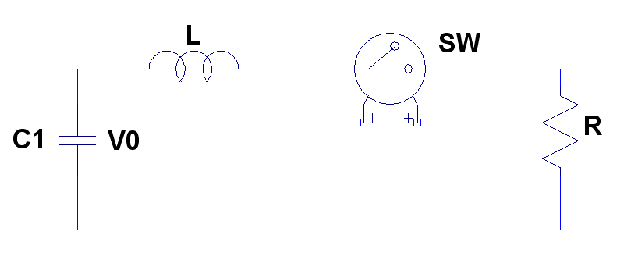
Figure 1. The simple RLC equivalent circuit of compact, portable high-current generator.

A pulse generator with a “matched” load $R=\sqrt{L/C}$ is, in general, able to produce higher pulse currents with faster rise times compared to the “critically matched” $R=2\sqrt{L/C}$ case, and is more suitable for the design of a radiographic x-pinch machine, as is discussed in [16]. In the “matched” case the peak current, voltage, and rise time (0-100 %) are given by the following expressions [16]:

,
,
,

where V₀ is the initial voltage of capacitor C.

description of compact, portable plasma-radiation-source generator with 180-ka peak CURRENT
We chose the General Atomics Electronic Systems fast-pulse-capacitor 35477 [12] with the following characteristics: inductance L_{c} = 10 nH, capacitance C_{c} = 100 nF, voltage rating V₀ = 100 kV, peak current I_{c} = 50 kA and maximum voltage reversal of 45% from V₀. Such a capacitor has a lifetime of 3 x 10³ cycles, a footprint of 102 x 152 x 241 (H x W x L) millimeters, an approximate weight of 5.9 kg, and is double ended, so it can be naturally connected to a switch in one single line. Four such capacitors would be enough to supply a total peak current of 200 kA.
The schematic of the proposed generator is presented in Fig. 2. The capacitor bank is comprised of four capacitors (C1-C4) initially charged to the maximum allowable voltage of 100 kV. Each capacitor is connected in series with a fast, high-current switch (S1-S4), which has the inductance value, L_{sw}, of 40 nH [14]. The total inductance of capacitor and switch, which is equal to 50 nH, is represented by circuit elements L1-L4. The circuit element L_{feed} represents the total inductance of all connection lines between the generator and the x pinch, and L_{x pinch} and R_{x pinch} represent the inductance and resistance of the x pinch, respectively.
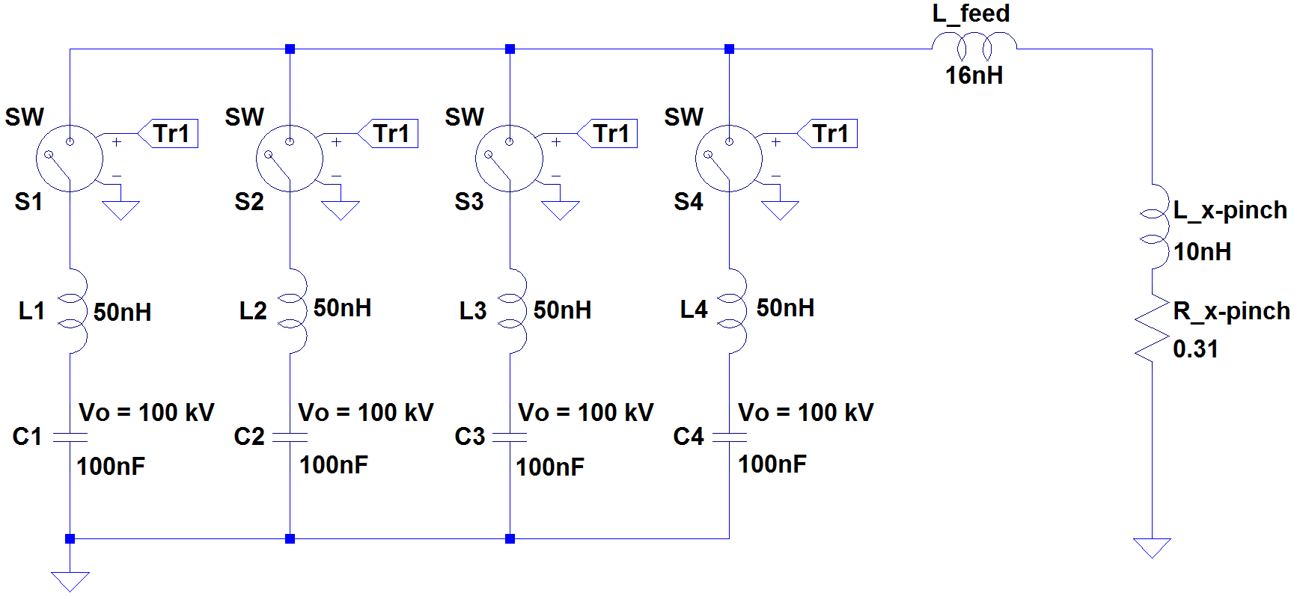
Figure 2. Schematic of a compact, portable high-current low-inductance generator composed of four, General Atomics Electronic Systems’ capacitors 35477 (C1-C4) and four, low-inductance switches (S1-S4).
The total capacitance of such a generator is equal to:

.

The x-pinch inductance can be roughly approximated by two wires connected in parallel. Taking two, 15-mm-long, 40-μm-diameter Mo wires, the initial total inductance of the x pinch will be equal to 10 nH. The inductance of all connection lines (header, lower feed, upper feed, etc.) can be estimated to be about 16 nH. Therefore, the total inductance of the whole generator presented in Fig.2 is equal to:

.

Using (4) and (5) we can calculate the “matched” load’s value as:

.

By formulas (1-3) above, the load peak current, voltage and rise time (0-100%) are:

,

,

.

LTspice simulation
We used LTspice [19] Linear Technology circuit simulation program to predict the behavior of the high current low inductance generator presented schematically in Fig. 2. There were several benefits in doing simulations. First, we verified the peak current, voltage, and rise time, calculated above by formulas 7-9; second, we looked at the current and voltage behavior of various separate circuit elements to predict how they are developed in time.
The results of simulation are presented in Fig. 3 (a, b) below. Four capacitors C1-C4 are initially charged to the
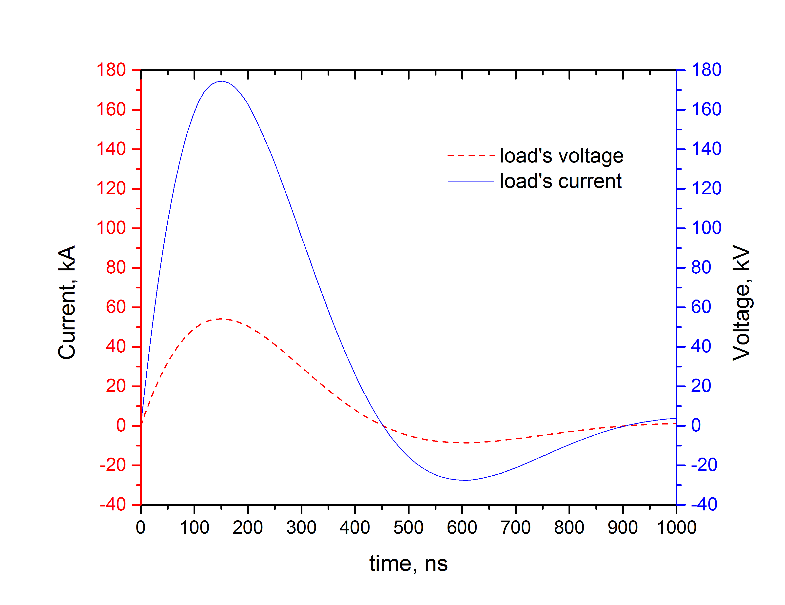  (a) | 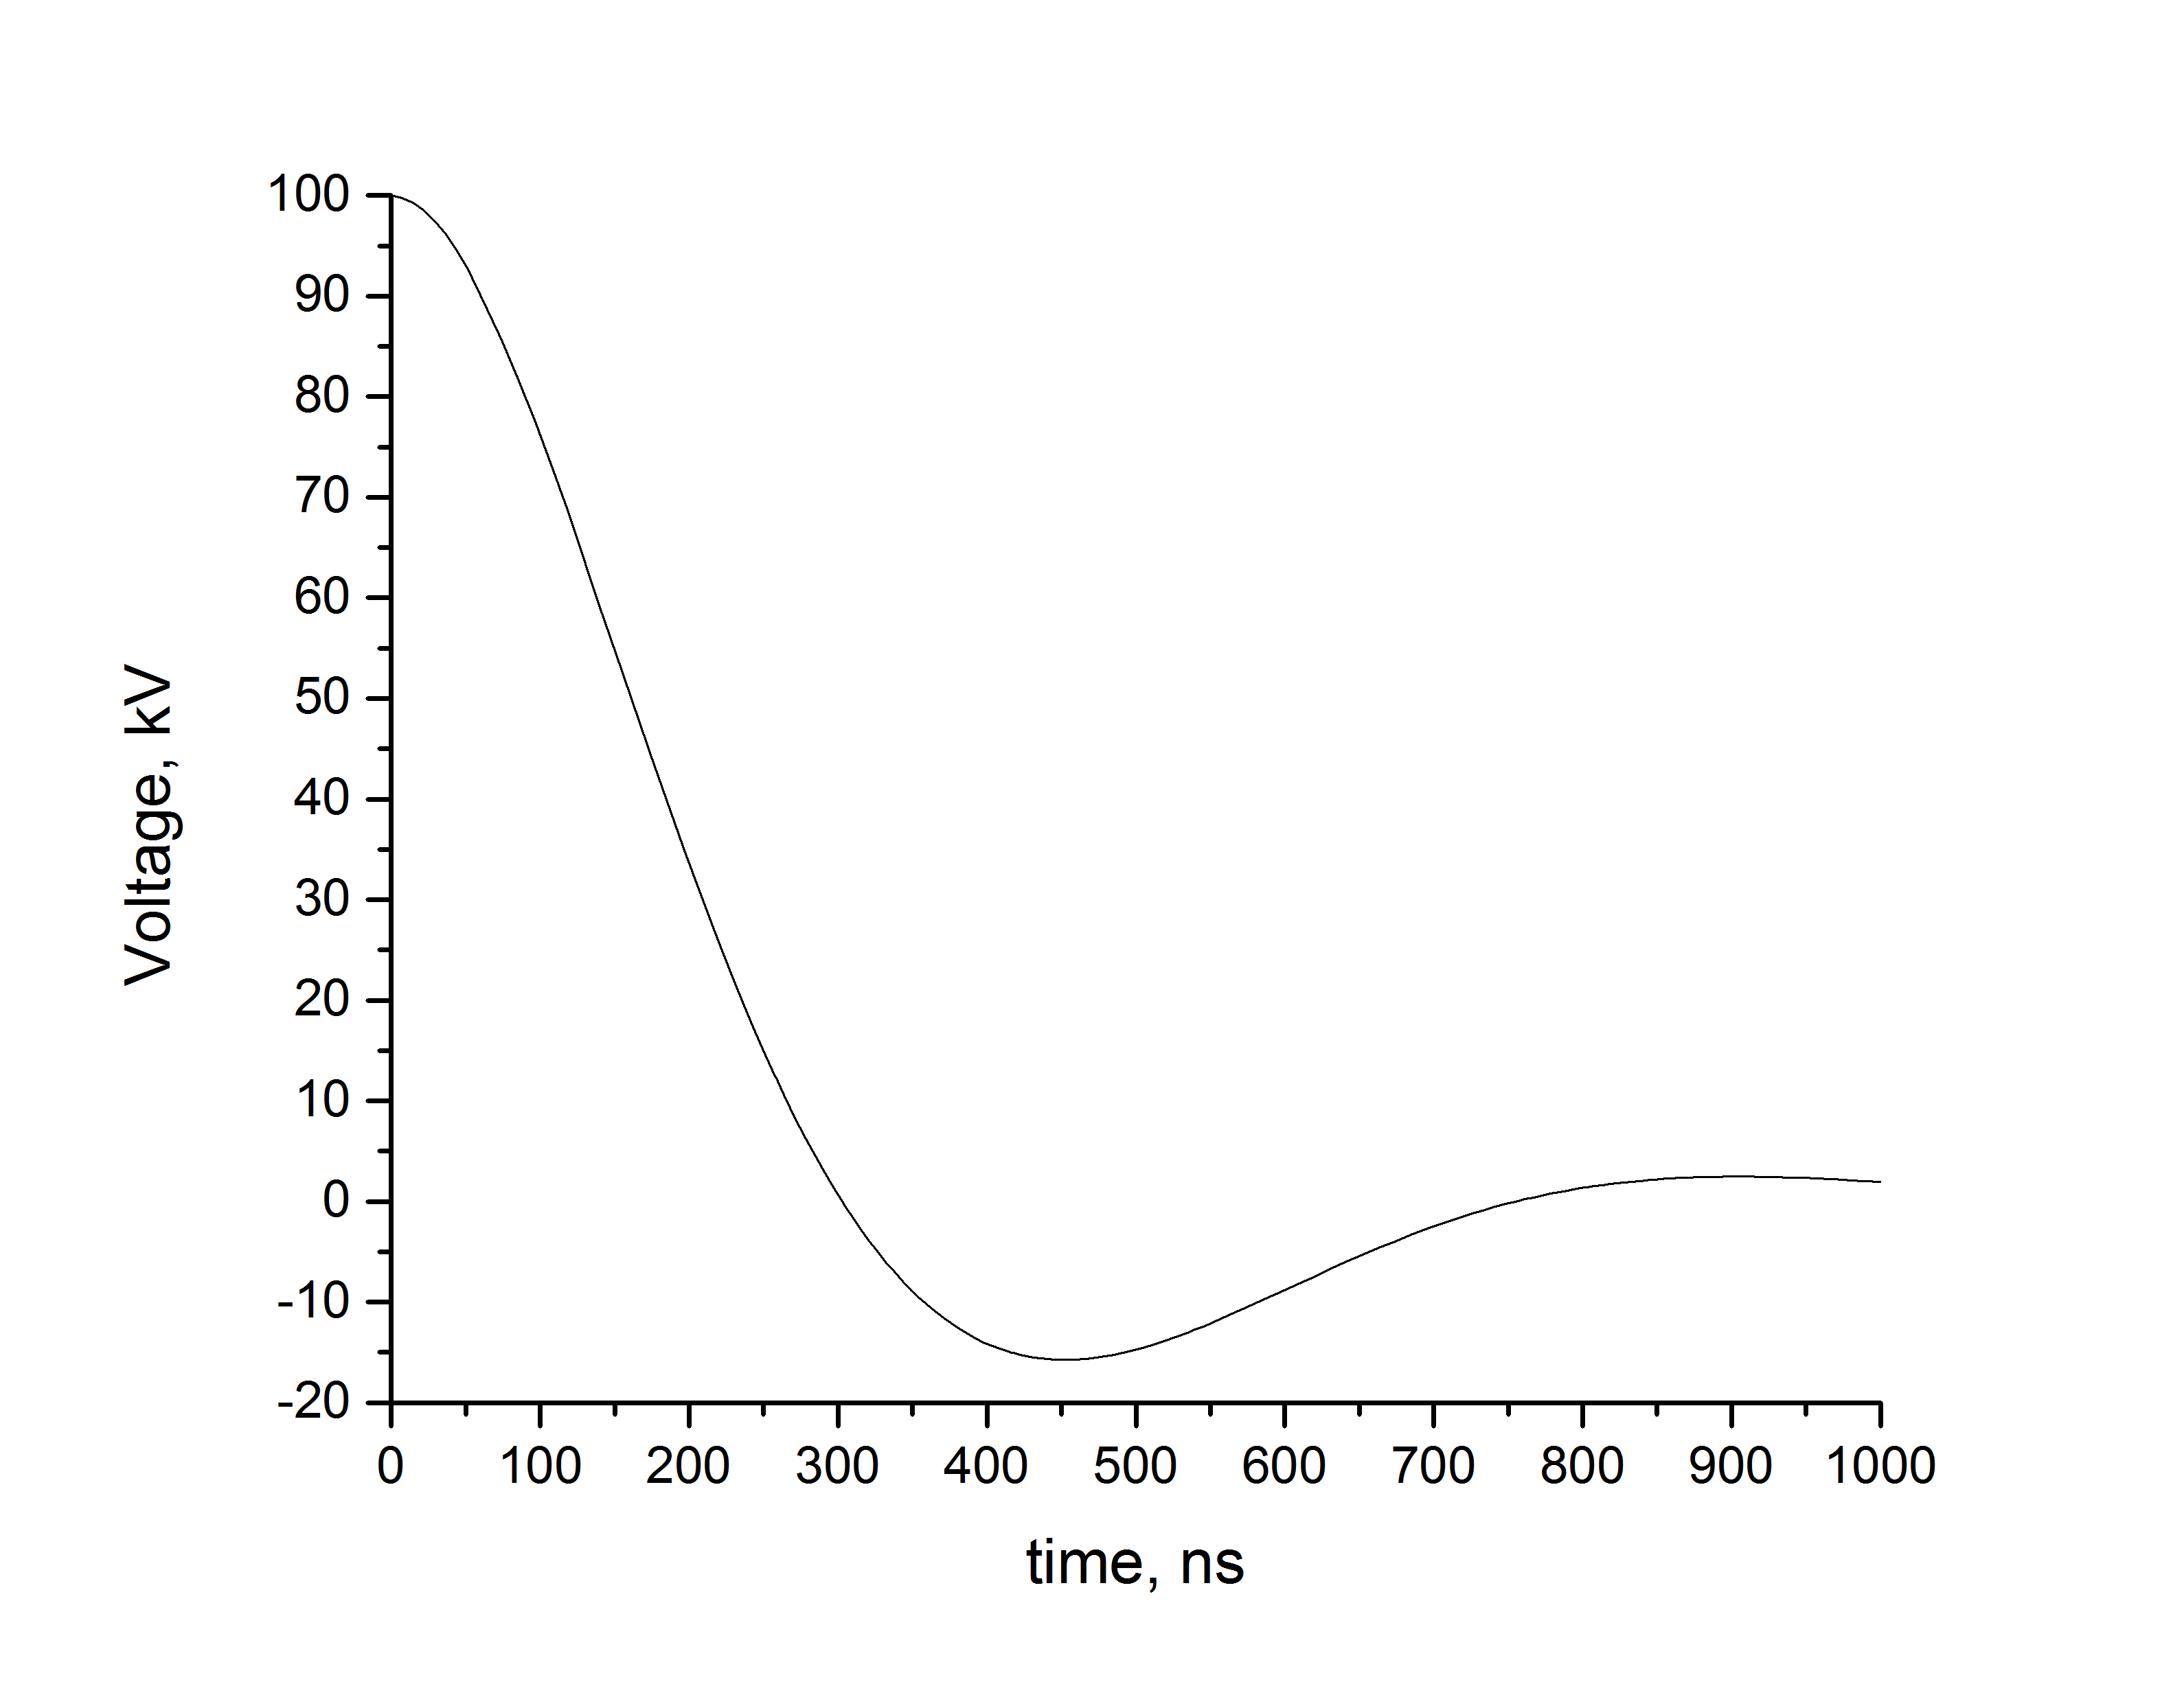  (b)
Figure 3. LTspice simulations of a high-current, low-inductance plasma-radiation-source generator for the “matched” $R=\sqrt{L/C}$ load case: (a) current and voltage measured on the output load (b) voltage measured on the capacitor C1.
maximum allowable value of 100 kV. After they were fully charged, at time t = 0 they are simultaneously discharged through switches S1-S4 into the “matched” x-pinch load.
The behavior of the current and voltage pulses as measured on the output load are shown in Fig 3(a). The load peak current, peak voltage, and rise time are equal to I_{peak} = 175 kA, V_{peak} = 54 kV, t_{peak} = 150 ns, respectively, which are in good agreement with the values calculated earlier by formulas (7-9). Fig. 3(b) shows the voltage measured on the capacitor C1 during the discharge time. The maximum reversal voltage equals -16 kV that is well below the maximum allowable value of 45% from V₀. The voltage behavior on the other capacitors is identical. The rate of the current rise (10-90%) of the generator can be found from the output current in Fig. 3(a) and equals$1.5 kA/ns$.

conclusion
In this paper we present the design of a compact, portable x-pinch plasma-radiation-source generator capable of supplying 180-kA peak current with 150-ns rise time. The rate of the current rise (10-90%) is found to be 1.5 kA/ns. A total of four, low-inductance high-current capacitors are discharged simultaneously in parallel into a low-inductance, “matched” x-pinch load. LTspice simulations shows the good agreement with predicted peak current, voltage, and rise time values.
The proposed approach is flexible and can be easily modified for higher or lower peak currents, if desired. Plus, by introducing, for example, small modifications in the values of different elements of the electrical circuit, we can study various scenarios such as: the misfire of one of the switches, the “jitter” effect and how it changes the shape of the output current, or we can make our generator “under” matched or “over” matched and look at consequences.
After construction and testing, such a device can be used in a variety of applications including, but not limited to, high-resolution, phase–contrast imaging of rapidly evolving small objects.

Acknowledgments
This work was partially supported by DTRA grant HDTRA1-11-1-0035. Thanks a lot to Dr. V. Dimitrov for introducing me to pulsed power science and to Dr. W. Beezhold and Dr. R. B. Spielman for their helpful discussions and comments.

References
1. S. M. Zakharov et al., Tech. Phys. Lett. 8, 456 (1982).
2. S. A. Pikuz et al., "High-luminosity monochromatic x-ray backlighting using an incoherent plasma source to study extremely dense plasmas (invited)," Rev. Sci. Inst. 68(1) (Jan. 1997).
3. T. A. Shelkovenko et al., "Studies of plasma formation from exploding wires and multiwire arrays using x-ray backlighting," Rev. Sci. Inst. 70 (1) (Jan. 1999).
4. S. A. Pikuz et al., "Density measurements in exploding wire-initiated plasmas using tungsten wires," Phys. Plas. 6(11) (1999).
5. B. M. Song, et. al., "Small size X-pinch radiation source for application to phase-contrast x-ray radiography of biological specimens," Nucl. Sci. Symp. Conf. Record, 2002 IEEE, pp. 868-872 vol. 2.
6. F. N. Beg et al., "Compact X-pinch based point x-ray source for phase contrast imaging of inertial conﬁnement fusion capsules," Appl. Phys. Let. 89, 101502 (2006).
7. T. A. Shelkovenko et al., "Multiwire X-Pinches at 1-MA Current on the COBRA Pulsed-Power Generator," IEEE transaction on plasma science 34(5) (Oct. 2006).
8. D. H. Kalantar and D. A. Hammer, "The x‐pinch as a point source of x rays for backlighting," Rev. Sci. Inst. 66, 779 (1995).
9. X. Zou et al., "A pulsed power generator for X-pinch experiments," Laser and Particle Beams, 24(4), pp.503-509 (2006).
10. Pontificia Universidad Católica de Chile, Optics and Plasma Physics Group: http://www.fis.puc.cl/~plasma/.
11. R. Zhang et al., "X-pinch Applications in X-ray Radiography and Design of Compact Table-Top X-Pinch Device," Power Modulator and High Voltage Conference, 2010 IEEE International.
12. General Atomics Electronic Systems Fast Pulse Capacitors: http://www.ga-esi.com/EP/capacitors/series-pds.php.
13. J. R. Woodworth et al., "Low inductance switching studies for linear transformer drivers," 2009 IEEE PPC.
14. L-3 PS high voltage switches: http://l3ndt.com/index.php?option=com_content&view=article&id=69&Itemid=66.
15. M. G. Mazarakis & R. B. Spielman, "A Compact, High-Voltage E-Beam Pulser," Pulsed Power Conference, 1999. Digest of Technical Papers. 12th IEEE International, pp. 412-415.
16. M. G. Mazarakis et al., "High current fast 100-ns LTD driver development in Sandia Laboratory," 2005 IEEE PPC.
17. A. V. Kharlov et al. "Compact high current generator for x-ray radiography," Rev. Sci. Instrum. 77, 123501 (2006).
18. Michigan Accelerator for Inductive Z-Pinch Experiment: http://www-ners.engin.umich.edu/labs/plasma/index.html.
19. LTspice IV Getting Started Guide: http://cds.linear.com/docs/en/ltspice/LTspiceGettingStartedGuide.pdf.

