A Mini Linac Based Positron Source at CEA-Saclay
P. Debu ª, L. Liszkay ^{a,b}, P. Pérez ª, J.-M. Rey ª, Y. Sacquinª, V. Blideanuª, A. Curtoni ª, O. Delferriere ª, P. Dupré ª, T. Muranaka ª, N. Ruiz ª
ªDSM/IRFU, CEA/Saclay, F-91191 Gif-sur-Yvette Cedex, France
^{b}CEMHTI, UPR3079 CNRS, Site Cyclotron, 3A rue de la Férollerie, 45071 Orléans Cedex 2, France
Abstract. We are installing at CEA-Saclay a demonstration setup for an intense positron source. It is based on a compact 5.5 MeV electron linac used to produce positrons via pair production on a tungsten target. A relatively high current of 0.15 mA compensates for low positron efficiencies at low energy, which is below the neutron activation threshold. The expected production rate is 5·10¹¹ fast positrons per second. A set of coils is arranged to select the fast positrons from the diffracted electron beam in order to study the possibility of using a rare gas cryogenic moderator away from the main flux of particles. The commissioning of the linac is under way. This setup is part of a project to demonstrate the feasibility of an experiment to produce the H⁺ ions for a free fall measurement of neutral antihydrogen (H). Its small size and cost could be of interest for material science applications, after adaptation of the time structure.
Keywords: Antihydrogen, Positron beam, Positronium.
PACS: 04.80.Cc, 07.77.Ka, 29.25.-t, 41.75.Fr

An Antihydrogen gravitation experiment
In order to produce slow neutral antihydrogen atoms suitable for a free fall measurement, Walz and Hänsch proposed using the H⁺ ion to collect ultra cold anti-atoms [1]. This ion can be cooled down to µK temperatures (i.e. m/s velocities). The excess positron can then be laser detached in order to recover the neutral H anti-atom. The temperature achieved in cooling of the H⁺ ion gives the main systematic error. Collecting 1000 events should provide a 2% measurement error on the gravitation constant g.
The Saclay group proposed a way to prepare such ions using interactions of antiprotons with a dense target of positronium (Ps) [2,3]. The charge exchange process p + Ps → H + e⁻ is followed by H + Ps → H⁺ + e⁻. Taking into account measured and calculated cross-sections [4,5], 10⁷ antiprotons interacting with a cloud of Ps atoms with a density of 10¹² cm⁻³ will produce 1 H⁺ ion, together with 10⁴ H atoms. The Ps density may be obtained by sending on the order of 10¹¹ slow e⁺ onto a converter such as the one we developed [6]. The proposed positron source is designed produce 10¹¹ slow positron flux within the lifetime of orthopositronium.

Positron production with an electron linac
In ref [7] the idea was proposed to use a low energy electron accelerator in order to achieve the high positron rates needed. The low positron production rates induced by the low incident energy can be overcome with a high average current. The energy is also below the neutron activation threshold, which is an important issue when considering the heavy regulations associated with radioactive installations.
We have purchased a small industrial linear accelerator from Linac Technologies [8]. Its nominal kinetic energy is 5.5 MeV and the average current 0.15 mA, owing to an impregnated cathode. The maximum repetition rate is 200 Hz with a bunch length fixed at 4 µs. The magnetron peak power is 1.9 MW. The total power consumption is 35 kVA. The acceleration length is 21 cm after which the beam diameter is 1 mm, increasing to 1 cm at 80 cm from the end of the acceleration section. The overall dimensions are roughly 1 m x 1 m x 0.8 m (Fig. 1).

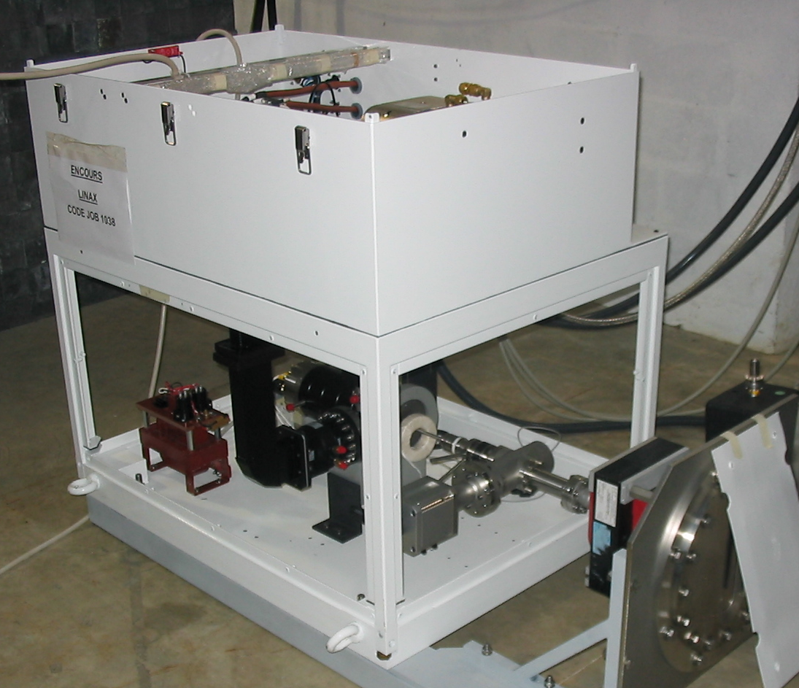
FIGURE 1. A view of the linac housing. The top part contains the magnetron and circulator, the bottom part holds the RF cavity.

Simulations, performed with the GEANT3 software package [9], predict rates of 5·10¹¹ e⁺·s⁻¹ when the beam hits a 200 µm thick W target at 5 degrees incidence angle. At such low incident energies the positrons are emitted almost isotropically from the target, with 2/5 of these positrons emitted backwards from the incident beam direction. The average exit angle with respect to the beam is large, of the order of 50 degrees and even larger for the lowest positron energies.
The average positron energy is 800 keV, with a large spread as the distribution extends from ~ 0 to 3 MeV [10].

Electron linac commissioning
The RF cavity requires temperature regulation at ± 0.5 degree. A demineralized water cooling system has been built for the linac and the e⁺ selection magnets.
The beam energy distribution has been simulated with the PARMELA software [11] and predicts a sharp peak at the nominal energy of 5.5 MeV with a long tail extending down to very low energies (Fig. 2). More than 90% of the flux is above 5 MeV.
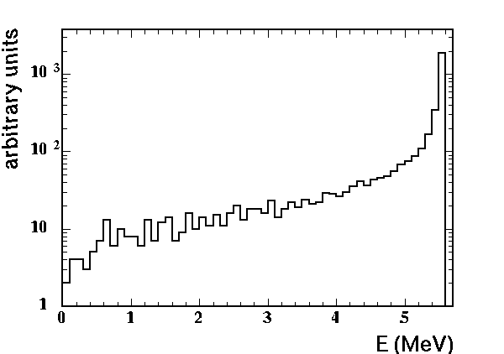
FIGURE 2. Electron energy distribution from the linac as simulated by the PARMELA software.

The beam energy has been measured with an aluminium block of variable thickness placed in front of a sensitive film. A maximum energy of 5.53 MeV was measured as expected. The beam spot was also measured with a sensitive film at 80 cm from the end of the RF section. The long axis of its elliptic shape is 1 cm wide as expected.
The intensity was measured with a torus placed around the beam tube in the linac, and by the intensity of the signals in the target or in a specially designed profiler. This intensity does not vary significantly from pulse to pulse. The average current thus depends only on the repetition rate. An average charge on the order of 720 nC per pulse was deduced from these tests. The average current is around 140 µA when run at 200 Hz.

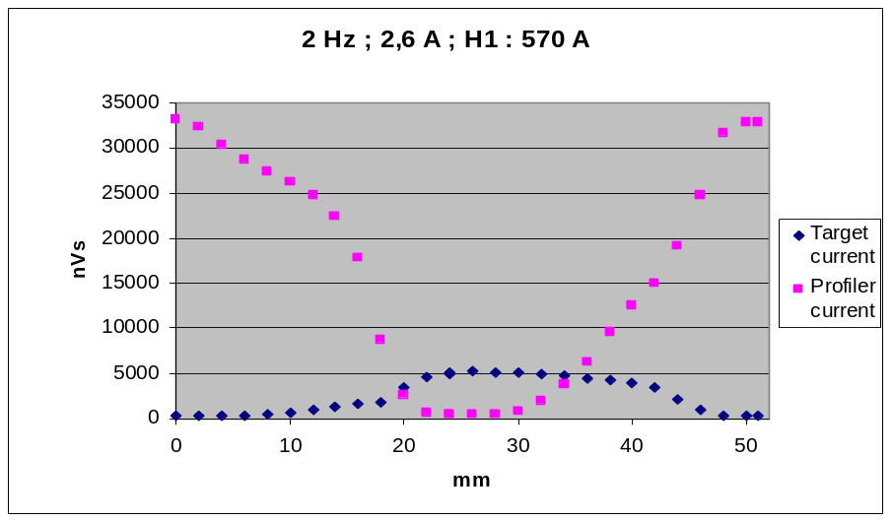
FIGURE 3. Scan of the beam with the profiler, indicating an elliptic size of the beam with σ ≈ 3 mm, due to the focalizing high magnetic field.

Fast positron selection
Behind the W target, a set of transport coils and a dipole magnet have been designed to separate the electrons from the fast positrons. At the exit of this facility, the positrons have to be moderated.
A tungsten moderator of 10⁻⁴ efficiency can be placed after the primary target, so that a flux of about 10⁷ slow e⁺s⁻¹ is expected. Another option is to build a moderator based on solid Ar, Kr or Ne at cryogenic temperatures, to be placed away from the diffracted electron flux [3,10]. We then estimate efficiencies at least 10 times higher after including transport losses due to the large beam size.
The complete setup containing the linac, the coils with their support, and the vacuum chamber has been installed inside an 8 m x 5 m x 3 m room with concrete shielding against X rays. The temperature regulated water cooling system which is used for the linac is scaled to also cool the coils. Ventilation is installed to evacuate the ozone formed inside the room.
The positron flux will be measured with a simple 32 pad device located at the upper end of the vacuum vessel, where the positron beam line will leave the setup and be guided to an electromagnetic trap.

Perspectives
Linac commissioning is nearly finished, and the cryogenic moderation is under study. We anticipate designing and building a high field Penning trap adapted to the linac time structure to accumulate up to 10¹¹ positrons for antihydrogen production [2,3]. Such a source may be adapted to the needs of material science research by transforming the time structure of the beam to be quasi-continuous using a simple low-field trap.

Acknowledgments
The linac has been bought with partial support from Conseil Général de l’Essonne under ASTRE 2006 funding. The fast e⁺/e⁻ selector is supported in part by Agence Nationale de la Recherche under contract number ANR-05-BLAN-0380-01.

References
1. J. Walz and T. Hänsch, General Relativity and Gravitation 36, 561 (2004).
2 P. Pérez and A. Rosowsky, Nucl. Inst. Meth. A 545, 20-30 (2005).
3 P. Pérez et al., in Proceedings of the Workshop on Cold Antimatter Plasmas and Application to Fundamental Physics, edited by Y. Kanai and Y. Yamazaki, AIP Conference Proceedings 1037, 2008.
4 J. W. Humberston, M. Charlton, F. M. Jacobsen and B. I. Deutch, J. Phys. B 20, L25-L29 (1987) ; J. P. Merrison et al., Phys. Rev. Lett. 78, 2728-2731 (1997) ; J. P. Merrison et al., Hyperfine Interact. 109, 313-321 (1997).
5 N. Yamanaka and Y. Kino, Phys. Rev. A 65, 062709 (2002) and references therein; A. Igarashi, N. Toshima, and T. Shirai, J. Phys. B 27, L497-L501 (1994); J. Mitroy and G. Ryzhikh, J. Phys. B 30, L371-L375 (1997); J. Mitroy and K. Ratnavelu, J. Phys. B 28, 287-306 (1995); H. R. J. Walters and C. Starett, Phys. Stat. Sol. C, 1-8 (2007).
6 L. Liszkay et al., Appl. Phys. Lett. 92, 063114 (2008).
7 P.Pérez and A. Rosowsky, Nucl. Inst. Meth. A 532, 523-532 (2004).
8 Linac Technologies S.A., 16 rue N. Appert, 91400 Orsay, France.
9 GEANT3.21, CERN Program Library W5013 (1994).
10 P. Pérez, L. Liszkay, J-M Rey, O. Delferrierre, V. Blideanu, M. Carty, A. Curtoni, N. Ruiz, Y. Sauce, Appl. Surf. Sci. 255, 33-34 (2008).
11 L. M. Young, "PARMELA", Los Alamos National Laboratory Report, LA-UR-96-1835 (Revised February 27, 2001).

