Special Topics
PHY 599
Instructor: Tony Forest

Monte Carlo Simulation of Monochromactic Laser Compton Scattered (LCS) X-rays

Syed F. Naeem
Advisors: Douglas P. Wells Khalid Chouffani
Committee Member: Tony Forest

- INTRODUCTION

  - LCS X-rays

Laser Compton Scattered (LCS) X-rays are produced as a result of the interaction between accelerated electrons and a laser beam. The relativistic electrons scatter low energy laser photons to a higher energy and hence also referred to as incoherent or Compton scattering of low energy laser photons. The direction of the back scattered LCS X-rays is governed by the direction of the electron beam, with divergence on the order of 1/γ, where γ is defined as the ratio of the incoming electron beam energy to the rest mass energy of an electron. [1]

  - Laser Photon and Electron Interaction Probability

The interaction probability or the differential scattering cross section that the photons, or laser photons in our case, will be scattered upon their collision with the relativistic electrons in Electron Rest Frame (ER) is simplified by Hartemann et al. [2] by representing the incident laser polarization vector as α´ and scattered photon polarization as η´ in ER frame as follows:
(1)
However, the differential scattering cross section was originally derived by Klein-Nishina [3, 4]:
(2)
Where dΩ´ = sinθ´dθ´ represents the solid angle of the photons being scattered in θ´ directions, r₀ is the classical electron radius, and R is the ratio between the energies of the scattered photons and the incident photons in ER frame. Hartemann et al. [2] and Stepanek [4] explained the production of LCS X-rays as by first transforming the incident laser photons into ER frame and then the corresponding ER differential scattering cross section being transformed back into the laboratory frame. Figure 1 shows the schematic of the electron and laser photon interaction process in Laboratory and ER frame.
E_{γ}

θ
E_{e}

E_{L}

E_{L}^{ER}

E_{γ}^{ER}

(E_{e}^{ER})´

m_{o}c²

φ
Lab frame

ER Frame

(E_{e})´

Figure 1. Schematic view of electron and laser photon interaction in laboratory and ER frame.
  - Lorentz Transformation

The ratio R between the energies of the scattered photons E_{γ}^{ER} and the incident laser photons E_{L}^{ER}, equation 2, in ER frame can be expressed as:
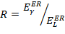 (3)
Lorentz transformation is used to boost the energy of incident laser photons from laboratory frame E_{L} into ER frame as follows [4]:
(4)

Where,
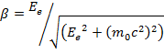 (5)
Kinetic energy of incoming electrons
= Electron rest mass energy, 0.511 MeV
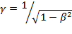 (6)
However, the Lorentz transformation, from laboratory frame into ER frame on z-axis, can also be expressed in matrix form that also includes the momentum of the photon both in laboratory frame and ER frame [5]:

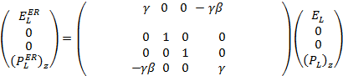 (7)

  - Energy of Compton backscattered X-rays

The yield of LCS X-rays is dependent on the laser power, angle of collision between interacting particles, and the electron linear accelerator’s (linac) electron beam energy and current. The energy gained by the backscattered X-ray photons is as follows [1]:
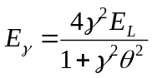 (8)
Where,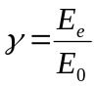, E_{e} is the electron beam’s energy and E₀ is the rest mass energy of an electron, E_{L} is the laser beam’s energy in electron volts (eV), and θ is the LCS X-rays emission angle in radians. The maximum Compton back-scattered photon energy can be estimated from equation 8 by assuming an approximate head-on collision between electrons and the laser:
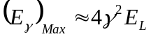 (9)

- METHODS AND MATERIALS (APPARATUS)

Geant4 is a Monte-Carlo simulation toolkit for the simulation of the passage of particles through matter and an ideal tool to investigate experimental parameters [6]. Compton process was used in Geant4’s PhyscisList class to simulate Compton backscattered X-rays (LCS) that were produced as a result of head-on collision between pencil-beam electrons and pencil-beam laser photons. Figure 2 shows the Geant4 graphical view of the interaction between relativistic electrons and laser photons and table-1 shows the energy of incoming relativistic electrons and laser photons and the resulting LCS X-rays energy to be determined in Geant4.

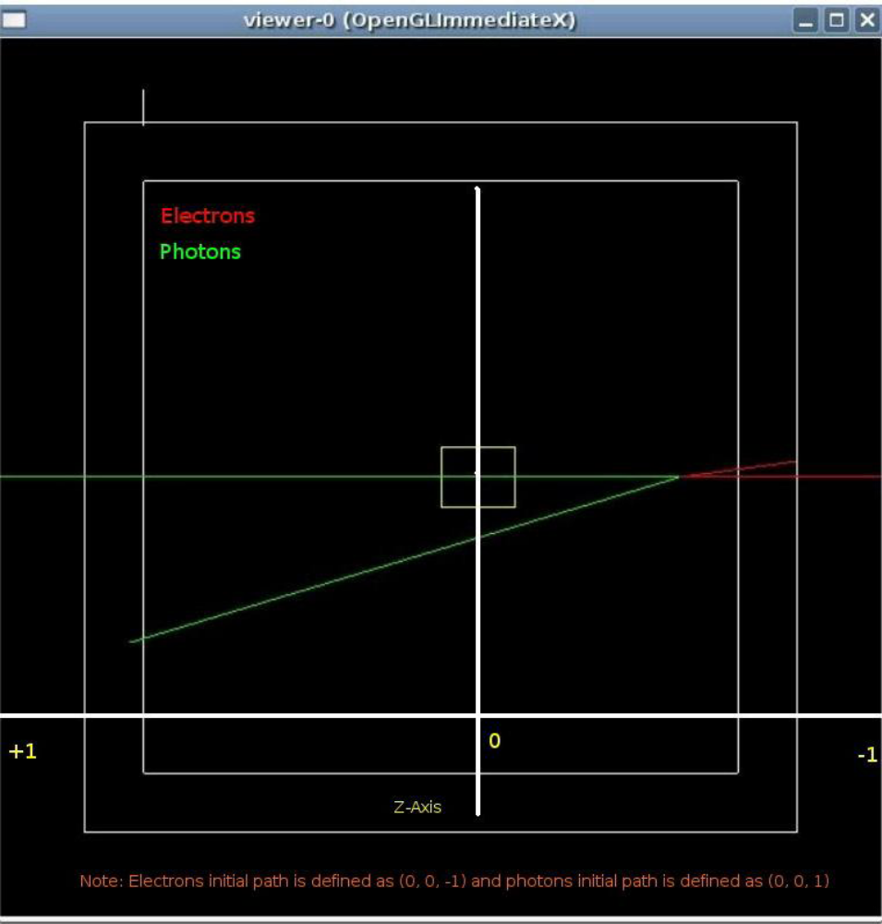
Figure 2. Geant4’s graphical view of the interaction between pencil-beam electrons (red) and pencil-beam laser (green).
E_{e} | E_{L} | θ  (Backscattered Compton X-rays emission angle) | γ = E_{e}/m₀c₂ | E_{γ}  (Eq. 8)
32.5 MeV | 532 nm = 2.3318 eV | 0 rad | 63.6007 | 37.72 keV
- | - | 1 mrad | - | 37.57 keV
- | - | 2 mrad | - | 37.12 keV
- | - | 3 mrad | - | 36.40 keV
- | - | 4 mrad | - | 35.43 keV
- | - | 5 mrad | - | 34.26 keV
- | - | 6 mrad | - | 32.93 keV
- | - | 7 mrad | - | 31.48 keV
- | - | 8 mrad | - | 29.97 keV
- | - | 9 mrad | - | 28.41 keV
- | - | 10 mrad | - | 26.86 keV
Table 1. Energy of incoming relativistic electrons and laser photons in laboratory frame and the resulting LCS X-ray energy using equation 8.

However, in order to simulate the interaction between relativistic electrons and laser photons and their corresponding backscattered Compton X-rays, the incident laser photons were first transformed into ER frame to interact with ER frame electrons and then the corresponding interaction result in ER frame, that is Compton back scattered X-rays, was transformed back into the laboratory frame.

As shown in table 1, the energy of incoming electrons to be simulated was 32.5 MeV and the laser photon wavelength was 532 nm. Following calculations, starting from equation 5, show the energy conversion of 532 nm (≈ 2.332 eV) laser photons from laboratory frame as follows:
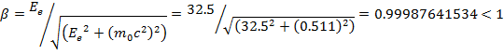

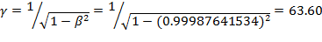

The final energy of the ER frame photon energy can be either calculated using equation 4 or 7:

Table 2 summarizes the laboratory and ER frame energy:

 | Laboratory Frame | ER frame
E_{L} (Laser photon energy) | 532 nm ≈ 2.332 eV | 296.612 eV
E_{e} (Electron energy) | 32.5 MeV | 0.511 MeV
Table 2. Laser photon and electron energy in laboratory and their corresponding energy in ER frame.

  - Lorentz Boost Implementation in Geant4

In order to “Lorentz Boost” the incoming laboratory frame photon into its ER frame, a custom global class "SharedLCSValues" was created to store incoming relativistic electron's energy to calculate β, γ, and LorentzBoost conversion factors:

LCSGlobals.hh

#ifndef LCSGLOBALS_HH
#define LCSGLOBALS_HH 1
#include "globals.hh"

class SharedLCSValues{
public:
SharedLCSValues(); //constructor
void setElectronEnergy(G4double);
G4double getElectronEnergy();
G4double getBetaCalculated();
G4double getComptonLorentzFactor();
~SharedLCSValues(); //destructor
private:
G4double IncomingElectronEnergy;
G4double BetaCalculated;
G4double GammaCalculated;
G4double ComptonLorentzFactor;
};

#endif

LCSGlobals.cc

#include "LCSGlobals.hh"

SharedLCSValues::SharedLCSValues(){IncomingElectronEnergy = BetaCalculated = GammaCalculated = ComptonLorentzFactor = 0.0;}

void SharedLCSValues::setElectronEnergy(G4double value){
IncomingElectronEnergy = value;

if (IncomingElectronEnergy <= 0)
{
G4Exception("LCSGlobals::LCSGlobals - Electron energy outside intrinsic process validity range");
}
}

G4double SharedLCSValues::getElectronEnergy(){
return IncomingElectronEnergy;
}

G4double SharedLCSValues::getBetaCalculated(){

BetaCalculated = IncomingElectronEnergy/(sqrt(IncomingElectronEnergy*IncomingElectronEnergy+0.511*0.511));
return BetaCalculated;
}

G4double SharedLCSValues::getComptonLorentzFactor(){

BetaCalculated = IncomingElectronEnergy/(sqrt(IncomingElectronEnergy*IncomingElectronEnergy+0.511*0.511));
GammaCalculated = 1/sqrt(1-BetaCalculated*BetaCalculated);

ComptonLorentzFactor = GammaCalculated*(1-BetaCalculated);

return ComptonLorentzFactor;
}

SharedLCSValues::~SharedLCSValues(){}

- RESULTS (OBSERVATIONS)

  - Monte-Carlo Simulation

LCS X-rays are produced when accelerated electrons collide with a pulsed laser and the laser and electron beam collision time is synchronized to produce backscattered LCS X-rays. Figures 3.1 through 3.3 demonstrates computer simulated, Monte-Carlo simulation in geant4 simulation toolkit [6], an ideal monochromatic LCS X-rays with peak energy at 35.05 keV with 34.98 keV rms, its angular distribution, and X-ray energy vs. angle, plots produced as a result of interaction between 32 MeV electrons, pencil beam assumption, and 532 nm laser.
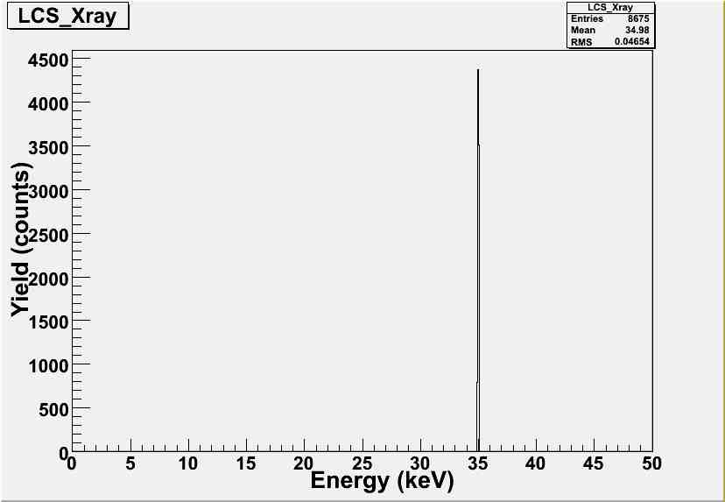
Figure 3.1. 34.98 keV LCS X-rays produced as a result of interaction between 32 MeV electrons and 532 nm laser.

References
- Chouffani K., Wells D., Harmon F., Jones J., & Lancaster G., Laser-Compton scattering from a 20 MeV electron beam, Nuclear Instruments and Methods in Physics Research A, vol. 495, pp 95-106, 2002

- Hartmemann F. V. et al, Characterization of a bright, tunable, ultrafast Compton scattering X-ray source, Laser and Particle Beams, pp. 221 – 244, vol. 22, 2004

- Klein O., Nishina Z., Physik, pp.853, vol. 52, 1929

- Stepanek, J., Parametric Study of Laser Compton-backscattering from free relativistic electrons, NIM-A, pp. 174 – 182, vol. 412, 1998

- Forest relativity notes, http://wiki.iac.isu.edu/index.php/Forest_Relativity_Notes#Lorentz_Transformations, 2009

- http://www.geant4.org/geant4/, 2009

- Chouffani K., et al, Determination of electron beam parameters by means of laser-Compton scattering, Phys Rev STAB 9, 050701, 2006

